GNU DataExplorer
(based on version 4.0.6)
Users Guide

Winfried Brügmann, June 2026
Table of Contents
Introduction 6
Why free software using GPL 6
A few words to Java 7
Used Directories 7
Execution on systems with high density displays 8
The Main Application Window 9
The Preferences Dialog 10
The Device Selection Dialog 15
Menu- and Tool- Bar 17
Menu "File" 17
Menu "Edit" 19
Menu "Device" 20
Menu "Graphics Templates" 21
Menu "View" 23
Menu "Help" 23
Outlet- Configuration-Data-Set Toolbar 24
Google Earth 25
KMZ Export Configuration 26
Shortcuts 28
Graphics View 29
The Curve Selector 30
Curve scale synchronization 33
Zooming and Positioning of Graphics View 34
Oscilloscope mode 35
Statistics View 36
Table View 37
Digital View 38
Analog View 39
Cell Voltage View 40
Curve Compare View 42
File and Dataset Comment View 43
Object Characteristic View 44
History Graphics View 45
History Table View 46
Device Properties Files 47
DevicePropertiesEditor 48
Data File Format 58
CSV2SerialAdapter Data Format 59
Actual Supported Devices 60
AkkuMaster from H-Tronic 60
Version information 60
Configure the data collection 61
Gather data only 62
Configured processes 63
Akkumatik from Estner 64
4D-Akkumonitor from epo-bike Racing 64
ArduPilot drone log analyzer 64
AV4ms (Firmware Version >= 4.67) from Mössinger/MEC 65
Core-Telemetry 66
Core-Telemetry Dialog 66
CSV2SerialAdapter 68
D100 and D100 V2 from SkyRC 69
D200neo from SkyRC 69
DataVario(Duo) and LinkVario(Duo) from WSTech 70
Data export in KMZ file format when using a GPS receiver 70
VarioTool - manage your setup file 71
eStations from Bantam 73
FlightRecorder from Multiplex 74
Futaba-Telemetry from Robbe/Futaba 76
GigaLogger from Simprop Electronic 76
GPS-Logger, GPS-Logger 2 and GPS-Logger 3 from SM-Modellbau 77
Device Setup 79
GPXAdapter 80
Herkules III Telemetry 82
Hitec RDX1, Hitec X1 Red 82
HoTTAdapter, HoTTAdapter2, HoTTAdapterM, HoTTAdapter2M to analyze reverse channel data of HoTT Graupner/SJ 83
HoTT-Viewer 85
iCharger206B, iCharger208B, iCharger306B, iCharger3010B and CellLog 8S from Junsi 86
iCharger from Junsi using USB connection 86
IGCAdapter to analyze IGC files 89
iMax B6, iMax B6 AC, iMax B6 mini from SkyRC 89
IISI Cockpit V2 from Matthias Isler, ESC GmbH 90
JetiAdapter from Jeti Model 91
JLog2 from SM-Modellbau 93
JLog2 Live Data Gathering 95
JLog2 Configuration 95
JLog2 and Telemetry 96
JLog2 and HiTec Telemetry 96
JLog2 and HiTec Telemetry and Digital Temperature Sensors at COM connector 96
JLog2 and HV2BEC, HiTec Telemetry and Digital Temperature Sensors at COM connector 97
JLog2 and GPS-Logger 97
JLog2 Robbe/Futaba BID Chip 97
JLog2 and 2 Sensors (Pulse Per Revolution, Temperature) 98
JLog2 and 2 Alarm Lines 98
Kosmik from Kontronik 99
LiPoWatch from SM-Modellbau 101
Tabulator „Configuration“ 101
Tabulator „Data I/O“ 102
MC3000 from SkyRC 103
Device Dialog 103
NMEA-Adapter 105
OpenTX-Telemetrie used by FrSky System 106
PichlerP6, PichlerP6 50W, PichlerP6 80W from Pichler 106
Picolario from Renschler 107
Configuration Tabulators 108
Picolario2 from Renschler 110
Polaron Charger from Graupner/SJ 111
All Polaron charger do not need a device dialog. After configuring the serial port just start live gathering the charging curves. 111
Power Peak from Robbe 111
Q200 from SkyRC 112
QuadroControl for QC-Copters from tt-tronix 113
S32 (Jlog3) from R2prototyping 115
Spektrum-Telemetry 115
Simulator 116
Ultramat, Ultra Duo Plus, Ultra Trio Plus from Graupner 117
Ultra Duo Plus Device Dialog Introduction 117
Data gathering 120
Automatic Object Selection 121
Battery Cycle Data History 122
UniLog from SM-Modellbau 124
Tabulator „Settings“ 124
Tabulator „Data I/O“ 125
Tabulator Configuration 127
Tabulator „Telemetry“ 129
UniLog2 from SM-Modellbau 130
Multiplex Sensors and Curve Names 132
Device Setup 133
UniSens E from SM-Modellbau 133
UT61E, UT71BCDE from UniTrend 134
VC820/840 from Conrad 135
Weatronic-Telemetrie 136
Weatronic-Dialog 136
Usage 136
Synchronization of measurements to a single scale 137
ZeroAdapter according LogView Specification 137

Introduction
The GNU DataExplorer is a tool to gather, view and analyze data which comes from devices with a serial data port, USB, TCP communication or import like CSV-file. The application itself runs on several operating system with 32 or 64 bit processor (GNU/Linux, Windows, Mac OS X) and is enabled for national language support. From 2019, the use of 32-bit systems continues to decline, which is why some external components and libraries are only maintained in the 64-bit version. Starting support of Java 21 it is no longer possible to compile byte-code for Java 8. Therefore only Linux for ARM_32 will be available as future release. Java 25 LTS will actually be used to build the integrated Java Runtime. Actual English and German is packaged. Devices might be data logger, measurement devices, charging devices or similar.
A fundamental idea for the development is the system comprehensive thought. For all variants usual computer operating system it should be possible to gather measurement data and present this graphically. Calculate statistics on the data as well. For instance current and voltage of charging devices, data measurable working with electric motors or back channel data transmitted from radio controlled vehicles. This is the reason to base the implementation on Java using the free available jSerialComm library, for the serial communication, libusb4java and the eclipse SWT library for the graphical user interface. For both libraries a native interface for Windows, GNU/Linux and Mac OS is available. For development the Eclipse IDE (integrated development environment) is used.
What is the naming for serial interfaces on different operating systems:
UNIX like operating systems will display the serial ports for selection without leading /dev.

Why free software using GPL
In fundamental there are two reasons. The software follows the freedom of software idea. Using GPL will makes the source code available for every one. Therefore the GNU DataExplorer makes all interfaces for device communication and the data model is freely available. This will finally gives everybody the power to enhance the applications (for own needs) with new functionality, add new devices and fix errors.
The device specific components are separate modules and are bind dynamically during run-time (plug-in). This enables developer to develop the device plug-ins disconnected from the main application. There is a sample implementation which can be used as entry point. To implement a device plug-in three facets are touched: the device itself, knowledge how to use the device and a communication specification (of course programming knowledge).

A few words to Java
A Java applications lives within extra for it started "Virtual Machine" (VM), this run-time environment is as fist approximation equal for all different system platforms. Therefore a Java application can be executed everywhere, where a Java run-time exist. The VM provides the available memory. Different to an application written in C a Java application can only use the memory provided by the JVM what is different to the system wide provided memory. This means while starting the JVM for a Java application the memory consumption limits must be provide (-Xms/-Xmx). If no values are provided, a maximum value of 128 Mbyte is used as default. A VM sounds like a system sandbox where there is no possibility to break through barriers. Would this the truth, there would probably no serial communication and no graphics library. Prior to announcement of the just in time compilers (JIT) Java applications are slow and came with its own visualization skin. Actual Java applications are very close to applications written in other programming languages in viewpoint of comfort and speed. Using the "Java Native Interface" it is possible to communicate direct with hardware device drivers. In this area mostly C applications are used to execute this job. This is the case with jSerialComm and as well SWT. Using Java a very big number of freely available libraries are available as well as libraries provided by GPL license. All of this can be used in commercial applications as well.

Used Directories
HINT: Please do not use an installation path containing special characters like mutated vowel. Java use as standard UTF-8 character encoding, while translating special characters can lead into an error situation.
Which directories are created during installation are described in the README file. More important are the directories used during run-time of the application storing settings, log files and graphics templates.
As base directory the application is using:
- Windows: %APPDATA%\username\DataExplorer
- GNU/Linux: /home/username/.DataExplorer
- Mac OS X: /Users/username/Library/Application/DataExplorer
At this start point for directories the following is used and created
- Devices: for device properties (XML) and device pictures
- GraphicsTemplates: for files describing the graphical properties like line color, number format, etc.
- Logs: for trace log files, do not mix with the device log data files
This should enough as overview. Later in this document we will dive deeper in details.
How get the data organized which contains the measurement values. A root folder or directory needs to be defined (refer to preference dialog), underneath each used device get its own data files folder. The device folder are the same as the chosen device names. In addition folder gets created for each created object. While saving the data a file name proposal according the configuration in preference dialog will be displayed. As example Date_Object_Name.osd. Is there a relation of the saved to an object, an object is selected while saving, a file link gets created in the object folder pointing to the file in the device folder. File links only needs a few bytes disk space, since its only a relation to the data file. There is no duplication of data files. While opening object related files only this object files are visible. As example you will find the battery of object XY when its last time charged.
A simple folder structure should give a better overview:

Hint: Since file links are operating system specific there is a capability to clean up and re-create all file links (refer to preference dialog). Moving your data to a different operating system is easy now.

Execution on systems with high density displays
Screens with high resolution (point density) are increasingly being used. Especially the most used operating system, Windows, is thrown here in some display situations. If system scaling is used, approximately 200%, it is necessary to adjust the compatibility settings of the executable file (DataExplorer.exe) in the properties dialog. Here you will find a feature "Behavior at high DPI resolution, change DPI settings", which make it possible to transfer the system scaling to the program. To do this, select "Overwrite high DPI scaling" and select "System" as the setting.

The Main Application Window
In the title bar of the application the name of the application itself and if applicable the loaded file name, the associated device name and the communication port name is displayed. As usual for this type of application a menu bar as well as a tool bar is available. The central area is build from windows reachable by tabs. This area will present the data in several form. The graphical view which presents the data using curves is the real main view. All other windows are detail views in other representation form.

At the bottom there is a status bar to display serial communication status, like connected, receiving and transmitting. Aside the communication port status a progress bar is placed to show progress of long therm operations. The rest of this status area is used to display warning messages or measurement results.

The Preferences Dialog
The settings dialog is used to configure:
- the language to be used
- the data path, where the application is locking for and placing the device specific log data files and file links.
- the file save dialog might be use the current date and/or object name as leader of the file name. This will help to find files.
- behavior of the device dialog. A primary modal behavior is some times not handy, if some adjustments are the place in parallel while gathering data. Some times this cost more effort while programming this.
- decimal separator and list separator characters. This might be different then the character used from system locale to work together with the spread sheet programs. This adjustment is used for import/export of CSV files, but has no influence while importing CSV2SerialAdapter Data Format files.

- using black-list or white-list configuration it is possible to configure according personal problematic ports (COM 2 COM5 COM18). This configuration is also valid for the device selection dialog, where device individual ports are selected. Configure the black-list will ignore ports declared. On the other hand the white-list will exclusive use the configured ports. Using the white list it is possible to miss ports dynamically configured by the system.
- while it scans for available serial ports and updates the results delayed. The delay can be reduced on slow systems by switching off the availability check. If this is the case used ports are displayed too which might not be used in future. At UNIX based systems this is not relevant. This adjustment reflect also to the device selection dialog which also scans for available serial ports.
- if system wide only one serial port is available it is possible to configure a global serial port usage, but in most cases the single available port will be found automatically.

The Tabulator "History" enable history analysis and its configuration. Overall, this type of analysis should be used for equal measurements coming through the same device from one object. For instance a history analysis doesn't make sense using measurements of all different batteries, LiPo, NiMH and different cell numbers, you ever charge with your charger.

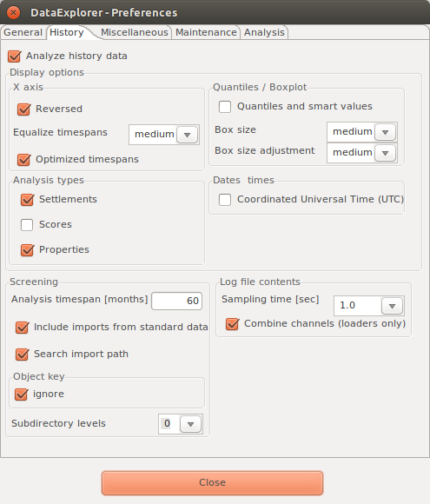

The configuration entries have tool tips to explain its advantages and what to be used for. In most cases you will see the change directly while have a history graphics view in background and modify the configuration settings.

Hint: Quartiles and smart values are additional statistical calculated values, gives the enhanced selection capability of the curves selector. Using this enhanced statistic calculation possible configured trigger doesn't get used anymore during history analysis.
More information related to history analysis you will find at history analysis view

Using the tabulator "Miscellaneous" it is possible to configure the graphics view. For better differentiation between the different curves and their dependent scale in the graphics view the record color can be used.
The outlet or configuration name can be used as leader of the record name in the curve compare view. This might make some curve source more clear.

The data table consist of a lot of columns. It is possible to reduce the visible columns to the measurement values selected in the graphics view. This can be adjusted using the context menu of the data table as well.
As well the behavior how to handle the recorded data can be adjusted for charging devices. Some charging devices allow data recording in pauses and after finishing the charging program. This can be switched off. In addition the complete charging discharging cycles can be recorded in a single record set.

The "Maintenance" tabulator contains some buttons to refresh or remove some application related items. Pushing the buttons will "Create Desktop Launcher" or "Remove Desktop Launcher" will create or remove such icons. The other two buttons enable the DataExplorer MIME type registration to associate the file endings *.osd and *.lov or remove this registration.

The button "Create Link Files" will scan all data files under the configured folder and create all missing object directories as well as the associating link files. The button "Clean Link File" will delete object related link files but not the object description files nor the object related directories. This function helps to move data files to different system/platform or for backup purpose.
Defining object keys may turn out as a cumbersome work: Speed up this task by pressing the button "Create Objects"! The system will scan the standard data path (and the import directory and identify 'object folders'. The object folder names are put in the object key list in the menu bar on the main screen which in turn allows you to select the log files more precisely.
The "Clear Cache" button clears the cache directory which is kept in your user account directory. However, clearing the cache is not necessary as it holds a minimum of aggregated data which is deduced from the original log files.
Using the button "Resource Consumption" will print the operating system handle usage status to the trace.log files.
Pushing the button "Clean Settings" the DataExplorer gets configures to remove all application configuration entries from the system while exiting. This includes Starter-Icon and other system entries and enable clean application removal or re-starting the application initial configuration.
Using the button "Resource Consumption" will print the operating system handle usage status to the trace.log files.
Pushing the button "Clean Settings" the DataExplorer gets configures to remove all application configuration entries from the system while exiting. This includes starter icon and other system entries and enable clean application removal or re-starting the application initial configuration.
Using the analyze tab only adjustments for problem analysis can be found. After a program failure function a trace log entry should appear which may help to find the reason for it appearance. Pay attention, modifying trace log level away from INFO will result in slowed down execution and may lead in unknown side effects. So adjust this values using this knowledge. The adjustments are scaled in detail level,
- SEVERE writes only program execution errors,
- WARNING writing errors and warnings, (default)
- TIME writing errors, warnings and time relevant log statements
- INFO writing errors, warnings and some informational,
- FINE writing all errors warnings and informational, in addition traces of the level fine,
- FINER writing more than FINE
- FINEST writing more than FINER

The below described part allows to configure the log level class based. To keep the log file content small do not adjust the log level above FINE. Otherwise the amount of log statements is very high.
- the global setting of the "trace log" level, is in normal the level INFO
- graphical user interface, here all statements are included called during main window execution
- devices, all statements called during device relevant execution
- data model, all executions involved by the data model itself
- utility functions, all the helper functions, drawing curves, calculate check sum, etc.
- file I/O, function calls involved in file input/output
- serial I/O, will used a memory logger above the level INFO to archive a low performance impact. As logical consequence the memory usage of the application is higher as before. It might be required to start the application using "java -jar -Xmx512m DataExplorer.jar" where the maximal memory usage is limited to 512 Mbyte.

The class based log level allows to set a logging level for selected class(es) which reduce the amount of trace statements and helps analyzing class centric. A context menu enables the log level selection. Closing the settings dialog will activate the adjusted trace level.
In every case only three level of trace log files are written with a limited size. The files in this rolled approach will over write after a certain amount of statements.
Hint: In case of error please have a look into the trace log files this will give help indicators to fix the problem (refer to Used Directories).

The Device Selection Dialog
Using the device selection dialog the devices are chosen which are available for the application. The device selection and port overview all devices are listed which are found by available device properties XML file in the "Devices" directory.

The selection of the active device will be done with the "Preferences" tab.

The selection of the active device can be done in several places on this tab. First place is the combo box direct above the device picture or with the slider at right hand side of the combo. The picture of the just selected device will be shown. Additional information related to the device is shown at the right hand side of the picture. Direct underneath this device info two selections are available to configure device specific behavior regarding device dialog and communication port.
Hint: Another possibility selecting the active device is using the next-/previous- device buttons in the tool bar.

Underneath the device picture the serial port must be selected. Is there only one serial port available at the current system this port will be selected for communication purpose automatically. The pictures below showing a port selection with COM4 using a Windows system and a port of a serial to USB adapter of a GNU/Linux system /dev/ttyUSB0.

With the “visualization preferences” group the visibility of some application tabs can be configured. Very small systems might be slowed down if to many data has to be updated while live data gathering.

The check boxes in the middle, Digital and Analog, are used mainly for live data measurements and have less sense for devices without this capability. If a device does not have live data capability or data are red from file the end values of the curve are displayed. The visualization of single cell voltages makes only sense for device with the capability to show this, mainly Lithium battery charger or balancer.
Check boxes in the lower section there are more device specific and can only be checked by changing the device configuration files.

At the lower area the serial communication parameters are displayed without the possibility to change it. Required changes can only be done by editing the device properties XML directly.

Menu- and Tool- Bar
The menu bar make all elements available to manage the application. The tool bar enable the most often used elements using icons to make it more intuitive.

Menu "File"
From the file menu all action are triggered with a file as base
- "New" initializing the application for the active device, are data available which are not saved this operation must be committed
- "Open" opens a file open dialog to select a file to be loaded. If the file does not fit to the active device the device gets switched while opening. File ending for supported input files can be adjusted as usual for your specific operating system.
- "Save" opens a file save dialog, are the data already saved overwrite commitment or renaming is required
- "Save as..." opens a file save dialog to use a new name to save the data
- "History" showing the list of last used files with a maximum of 10 entries
- "Import" offers the possibility to import device specific comma separated values files (CSV) files or raw data. In case of device capability an extra menu would be offered like *.cvs, *.nmea, *.txt or *.bin. Please do not mix with CSV data which gets imported with CSV2SerialAdapter or derivates which gets imported as initial device data import.
- "Export" offers the possibility to export comma separated values" (CSV) files as absolute values or raw data to be used for personal analysis like spread sheet programs.

Some device offers additional data export capability, example KMZ Google Earth files or IGC formatted files generated from GPS data.
- "Preferences" opens the preferences dialog to configure application properties
- "Print" opens a print configuration dialog to initiate printing
- “Start Time” opens a dialog to change the data set start time stamp
- "Exit" close the application (some temporary created files might be also deleted)
Hint: Absolute during CSV export means the same form as displayed in the table view. Raw means the data are equivalent to the data red from the device. While reading raw data the values are adapted if required according the device properties file, just as the data would be gathered from the device.
All functions of the file menu are available by the tool bar.
As sample the printing dialog s get reached both ways. It is possible to configure the views to be printed, according to availability, and page formatting. Using portrait print direction two views will fit to one page.
The printer selection dialog is a pure Java dialog due to actual color transformation problems using SWT.

Menu "Edit"
Using the edit menu the graphical data can be zoomed or shifted. The main copy operations into clipboard are located here as well.
- "Zoom Graphics Window", activated the capability to enlarge curve areas to enable detail views or detail measurement
- "Zoom Fit to Window" resets the graphics content to fit whole data
- "Pan Graphics Content" enables shift of enlarged graphics content to position area of interest
- "Copy Visible Tab Content" will copy an image of the just visible tabulator into clipboard
- "Copy Graphics Print Image" will copy the content of curve graphics or curve compare graphics as it would be printed into the clipboard
Hint: Copy and change fore- and back-ground color is also available for all tab windows using the context menu (right side mouse button)
All the functions to manipulate the graphical view are available by the tool bar. The tool bar gives additional capability to zoom the view or crop the dataset.

The sample below showing a positioning of transparent area, the area to be cut. A pop-up dialog ask for commitment. This will create a copy of the original data set with the cut edge. The user can decide each case to delete the untouched data set by itself.

Data sets with cut edge have an under bar character appended to its name. The original data set is still available.
Hint: Data set names may edited after pushing the edit button as documented here.

Menu "Device"
This menu enables device specific operations
- "Device tool box" opens the device dialog of the active device
- "Open/Close Port"; "Start/Stop Gathering"; "Import data" activates the configured function for the actual device
- "Device Selection Dialog" opens the dialog to select a device
- "Previous Device" switch to the previous device in the device list
- "Next Device" switch to the next device in the device list
- "Device Properties Editor" opens the device properties editor to adapt device properties (not all property changes will update results dynamically)

All device specific functions are reachable using tool bar buttons.

In addition there is a way not to sort your data according devices only, instead you can define and use objects across all devices. Using "device oriented" there is no change at all.

But if choosing or, using the plus sign, create a new object key, a new tab window, Object characteristic, appears. While a new object name gets edited finalize this with the Enter key. This will create a new object directory below the configured standard data path. Within the object characteristics tab it is possible to describe the object, which is actual selected. While selecting an object key the usage of the object key for the actual data set will be queried. Independent of the answer, starting from now, only data files are displayed while opening which contains this object key. Please note that the 'Create Link Files' as well as 'Create Objects' wizard in the setting window (tab 'Maintenance') fills or complements the object key list from your individual sub-directory definitions.

Menu "Graphics Templates"
Using this menu graphics templates are managed. Graphics templates contains graphics visualization properties.
If available and applicable a graphics template will applied according the device and channel configuration. Graphics templates contains properties regarding the once adjusted by the context menu of the curve selector, like line color, number format, ... The directory to the graphic template files "GraphicsTemplates" under the application configuration path.

- "Save Default Graphics Template", stores a template according channel configuration and device (DeviceName_ChannelConfigurationNumber.xml)
- "Load Default Graphics Template" loads a template according channel configuration and device (DeviceName_ChannelConfigurationNumber.xml)
- "Save Graphics Template as..." opens a file save dialog to save a graphics template with a given name, where the selected folder will not be recognized
- "Load Graphics Template" opens an 'open file dialog' to select a graphics template to be applied
If there is a reasonable configuration displaying all your important curves found, go ahead and save such graphics configuration as default.
The graphic templates contains definitions to adjust scale end values. Using devices which support live data gathering this could be important to judge the curves. Keep in mind, while displaying curves always the complete scale values margin will be used to display curves if not other specified. In cases curves with minimal deviation values could be displayed very similar to curves with ten times of the values. Only the scale end values will change. In similar case it would be advisable to configure a graphics template which have the maximum scale end values configured. Loading this graphics template at the beginning of live data gathering, the scale end values keep the same as configured until end of measurement. As sample a live data gathering of the QuadroControl. The QuadroControl will drive counteraction according to movement direction and force using its tree-axial accelerometer. To keep this in mind is important using the oscilloscope mode, were only a smaller part of the curve remains visible.

Hints: The apply function of graphics templates overlay with visibility configuration for some devices. If there are some curves switched invisible using the visibility configuration of the certain device, they will not be visible by applying the graphics template. Some devices switch curves invisible automatically in cases where no real data are contained. Devices with visibility configuration are as example CSV2SerialAdapter, WStech Varios, GPS-Logger, NMEA-Adapter, UniLog and some others. Using the visibility configuration dialog such curves can be made visible again even if they do not contain reasonable data.

Menu "View"
With this menu the curve selector can be hide or made visible. In addition a graphics header and data set comment can hide or made visible. This can be done using the context menu as well.

Menu "Help"
Using the help menu this text can be reached and the about dialog can be opened to check the version number of this application. Selecting the version check the home page of the DataExplorer can be reached to check if a newer version is available. No personal data are getting transferred to the Internet, only the URL is invoked.

Outlet- Configuration-Data-Set Toolbar
Depending on the device's characteristics and implementation, the combo box on the left represents either a device output or a configuration. A charger with multiple ports that allows multiple batteries to be charged simultaneously enables you to select the program flow to be displayed, based on the connected battery and its device data output, using the arrows next to it.
However, this dropdown menu may also represent a configuration that, for example, corresponds to specific properties in telemetry data. In the case of a configuration, the device description contains the relevant links. Different configurations can also be selected using the arrows.

Each configuration is associated with the statistical processing of data relevant to its intended use. For example, this includes the duration of the motor runtime, the power consumption during that time, the maximum height reached, or ...
The application remembers which outlet or configuration was last used and restores that selection the next time the program is started, depending on the device.
The data set to be displayed can be selected be the other combo box. Analog to the outlet channel/configuration there are buttons to switch to previous or next data set if applicable.

At the left hand side there are buttons to enable data set name editing or deletion. After pushing the edit button the cursor within the data set name field is activated for editing, a hit to enter commits this operations.
The buttons for cropping the dataset are always active and have been moved here. In earlier versions, cropping was only possible when zoomed in, therefore the buttons were located in the corresponding toolbar.

Google Earth
If the current displayed record set contains GPS (global position system) data it is possible to export a KMZ file and launch with such file the Google Earth application. Google Earth needs to be installed. The globe icon will change its visibility to signal launch capability.

Hint: Temporary files gets generated while using the globe button. This temporary files gets located in the temp folder of the system and get deleted while closing this application. If this files should be saved, change into the temporary folder of your operating system or export the same content using the export functionality (Export - KMZ 3D track).
The KMZ export, along with its flight path, can be color-coded in relation to other data. This must be configured before exporting via the KMZ Export dialog. Shown here as an example is the flight recorded using the DataVarioDuo with GPS. The color changes correspond to the predefined speed ranges.

Another example shows elevation changes (climb) highlighted in color in a section of a flight path that has been cropped by zooming.

KMZ Export Configuration
The dialog shown allows you to select the measurement value to be used for color coding and to configure the color ranges. The left side is used to configure the colors for the three possible ranges (Speed the example shown).

The dialog is shown twice to illustrate the differences in how the average factor is configured (blue border). If the average factor is set to 0, the fields for configuring the minimum and maximum values become active and allow for input. If the mean factor is greater than 0, the minimum and maximum values are automatically calculated based on it. The average value is displayed as a guide.
The start altitude correction is used to compensate for errors/tolerances/deviations in the Google Earth terrain model. When the Google Earth terrain model is enabled, it enables that the entire track is visible. When set to -1 m, the start altitude correction value also allows for export using relative elevation to ground level. This setting will produce satisfactory results in most cases. Only on slopes does the flight path tilt relative to the slope and appear distorted. In such cases, it is better to determine the Google Earth terrain elevation of the starting point and adjust it using the correction value. To do this, the terrain model must also be enabled in Google Earth. This results in exports using an absolute altitude, relative to MSL.

Hint: The exported GPS data in form of KMZ files contains data points which gives more info regarding the data point to you while this is switched on. It is possible to display a so called elevation profile using the context menu. Using the time bar on top a motion animation is possible
.

Shortcuts
Some functions are accessible by so called shortcuts. Below you can find the overview of implemented once. Shortcuts hints are visible while opening the menus.
On Mac OS X replace Ctrl with Command and Alt with Option.

File
New | Ctrl+N
Open | Ctrl+O
Save | Ctrl+S
Save as | F12
Import data | Ctrl+I (if supported by device)
Preferences | Alt+P
Print | Ctrl+P
Exit | Ctrl+W or Alt+F4 (Mac OS X Cmd+Q)

Edit
Copy visible tab content | Ctrl+Shift+T
Copy graphics print image | Ctrl+Shift+G

Device
Device tool box | Ctrl+T
Device selection dialog | Ctrl+D
Switch to previous device | Shift+Cursor left
Switch to next device | Shift+Cursor right
Device Properties Editor | Ctrl+E

Graphics Template
Load Default Graphics Template | Ctrl+L

View
Next tabulator | Ctrl+Page down
Previous tabulator | Ctrl+Page up
Previous outlet, channel or configuration | Ctrl+Cursor left
Next outlet, channel or configuration | Ctrl+Cursor right
Switch to previous record set | Alt+Cursor left
Switch to next record set | Alt+Cursor right

Help | F1(Windows/Linux)
Context help | Ctrl+F1(Windows)

Graphics View
The graphics view represents the real main window of the application. Here the data sets are represented as curves. With checking the individual cure names it will toggle curve visibility (refer to GraphicsTemplates). Many curves displayed might reduce clearness. This is the reason to have this check-box in direct access.

The curve names are colored equal to the curves to see direct relationship. The curve selector represents in this terms the legend and enables visual activation by a mouse click.
Much more configuration possibilities are accessible using the curve selectors context menu. It enable configuration of visibility properties as well as scaling properties.

Using the context menu (of each tabulator) it is possible to configure it visualization

The Curve Selector
To keep the data compact, the curve selector only displays the names of measured values that contain meaningful data. For some devices, such hidden measured value names can be switched on via the device toolbox.
The curve selector context menu gets activated by selecting a curve name with the right mouse button. On top of the context menu the name of the selected curve is written which is in focus. All adjustments and visualization changes are applied to just this curve.
Using the context menu Curve visible the curve can made visible or invisible. While the curve is invisible and some properties gets changed it will be visible afterwards. As sample an invisible curve should be measured, the curve gets visible and the measurement point are displayed.
Selecting Curve line color a color selection dialog pops up to chose the curve color. The selected color gets also used drawing the base line of the vertical scale of this particular curve to get easy color match. This color is used to display the digital numbers and the circle base line of the analog display.
Adjusting Curve line width the curve gets differentiated from the others.
Changing the Curve line type will only small change the visibility. Since the most curves has such small difference between data points there are only small impression changes. This has to be tested individually.
Some battery chargers will drop the charge current for measurement purpose. This might result in bad curve visualization. To make curves more clear it is possible to activate Smooth current drop function. Since the smoothing result depends on curves itself it can be activated or de-activated on demand.

The next block Axis end values manipulates the scales. Automatic uses the real minimum and maximum values of the curve. Rounded, rounds depending of the values in use. The selection of starts at 0 can be used together with “rounded” or “automatic”. The starting point of the scale is set to zero.

While selecting manual a small dialog gets active to enable adjustment of the end values. Values can not only changed by combo box selection it can be overwritten as well. Pushing the OK button or hit the enter button of the keyboard will close the dialog and make the changes active.
With the menu Axis number format the precision of the displayed values gets adjusted. To many digits might suggest a precision what is not real by means of the measurement device itself. Selecting automatic will adjust this according to the actual displayed value range. Axis position defines the side where the scale of this measurement is displayed.
The context menu to adjust grid lines enables displaying vertical, time line and horizontal, for the measurement. The color adjustments enables to leaf the grid lines in background. For vertical grid lines, time line related, the “mod 60” reduces the grid lines to minutes (60 sec) or hours(60 min) depending on the time line scale.
Horizontal grid lines are bound to only one measurement. The curve name used to adjust this will be displayed. Each second will only draw a grid line each second major scale mark.
The context menu Measurement it is possible to measure curve points with snapping crossing hairlines. To do this select the menu measure curve point. To move the hairlines position the mouse pointer direct over the vertical line. While the mouse pointer changes to arrows push the mouse button and move the hairlines to the point of interest. Meanwhile the measured value is displayed in the status bar.
The measuring point can also be set directly by holding down the Shift key and left mouse button. This selects the measured value whose curve is closest to the mouse pointer.
In the settings you can choose whether a pop-up with the current measured values is displayed or a table instead of the data set comment. This can be important if a Linux system is used whose window manager does not allow the positioning of such a window.
If the data set description is visible, use context menu, all values of selected measurement values get displayed in table form while measuring. To configure the short names of the measurements use the mapping file. For each measurement we have key value pair. The mapping file can be found below %AppData%\DataExplorer\Mappings.
To measure point difference the difference between two point are measured using two different crossed hairlines. The delta value and unit gets displayed in the status bar.

As measurement hairlines black and blue hairlines are displayed. Adjust both as described before to measure a single curve point value. Especially in zoomed curved this makes sense. As additional information the starting point of the zoomed area is displayed.
As additional possibility Average and Median could be calculated using the two point differences measurement.
The last sections in the context menu are used to copy selected curves into the compare window Copy to curve compare. The last entry allows to clean the curve compare view by selecting Clean curve compare. This entry gets active when at least one curve is within this area.
Hint: The actual release allows comparing curves of same measurement unit, like measurements from a battery then over the year. It is senseless to compare voltage with height as example. In case of none matching curves the application will display a warning message.

Curve scale synchronization
If there are curves of similar type an extra selectable entry within the curve-selector will be displayed. Selecting this entry the scales of the curves will be merged while synchronizing the end values. As sample voltage curves of Lithium cells are named. The comparison of the two following screen shots should make this more clear.

This will make more room for the curve display itself and the minimum and maximum values are the same. Through this the curves are easy comparable and a manual adjustment using the context menu is obsolete.

Hint: The synchronization of curves needs to be configured using the device properties editor (refer to measurement properties).

Zooming and Positioning of Graphics View
Activating zoom function changes the mouse pointer to a cross hair. Pushing the left mouse button defines a corner of the area to be zoomed. While keep the mouse button pushed and move the cursor a rectangle gets visible which defines, after releasing the mouse button, the area to be zoomed. An area created by moving the mouse from left to right, defines the zoom area, an area created by moving from right to left resets the zoom.
Hint: If its required to zoom only in one direction the start and end corners can be positioned outside the curve client area. This can also be archived by holding down the x-button for horizontal zooming, as well as by the y-button for vertical zooming. While a section is zoomed it is possible to zoom another section again. Turning the mouse wheel will zoom in or out depending on the direction.

The pan mode changes the mouse pointer into a hand. While keep the mouse button pushed the curves can be moved.
Reset the zoomed section using the fit to window function.
When in zoom mode, you can temporarily save this or other window sections. To do this, use the plus button between the two arrows in the zoom toolbar. If you have saved one window section, you can make it visible using the arrows in the zoom toolbar. You can delete the window sections by selecting the trash can icon in the zoom toolbar.

Oscilloscope mode
To display a zoomed section of the last measured values, while gathering data, a pull down menu can be used to adjust the size of measurement points to be used. The resulting view is similar to an oscilloscope.

At the menu tool bar the pull down is marked up which just show a selection of the last 50 measurement points to be displayed. Below the time scale the time value of the masking time frame will be displayed. This gives an overview about the total time consummation of the measurement. The sample showing four balanced voltage curves of Lithium cells.
In opposite the Cell Voltage View displays only the last actual measurement.

Statistics View
The statistics window shows statistic values for all measurements which can be displayed graphically. The device properties file hold all configuration required to calculate statistic values. Columns behind minimum / maximum shows the time at which the event was found.
Configuration of a trigger will enable to reference all statistic calculation to the measurement point within. In addition a trigger will enable to summarize all maximal values within the trigger area. This is shown in the sample screen shot below by height. Declaring a comment for each line of measurement it is possible to make clear referencing trigger.

Should the statistics configuration being adapted for some case the DevicePropertiesEditor must be used called from menu bar or as stand alone application.

Table View
The table is showing all data even if a curve is invisible. Depending on the amount of data the size of the table can be real big.

Big amount of data making the table unclear. This is the reason to have the capability to disable this calculation individual for each device (visibility configuration).
Hint: Using a cursor it is possible to navigate within the table and select table content. Afterward the selected part can be copied into clip board by Ctrl+C as usual. Typing Crtl+A and Crtl+C the complete table gets copied into the clip board. This can take several seconds depending on the table size. Afterwards the clip board content can be past into an opened table calculation application.
Hint: The time column can be switched to show date and time instead of the running time by using the context menu. The shown date time format will be yyyy-mm-dd HH:mm:ss:SSS. This is the format which is used during CSV file export as well.

Digital View
The digital view should be set to display actual measurement values during data being captured. For example a charger will query every few seconds a new measurement, this can be displayed and with the big letters its easy to read. The color of the numbers match the color which is adjusted in graphics view.

As mentioned no calculation are done only the measured values are displayed. The precision of the values match the adjustment of the precision of the graphics view.
This view will update its values only while capturing live data. So it is possible to deactivate this tabulator if this seams not required for this particular device (refer to desktop configuration).
Hint: Displayed values represent active and visible measurements from graphics context menu, the same precision is used as configured. The size of the displayed values can be changed. Anyhow this view targets to display only a low number of measurement values to keep overview.

Analog View
Similar to the digital view the analog view displays active measurements selected in the graphics view curve selector context menu. The screen shot below is showing the same measurement as shown for the digital view to make it comparable. The color of the scale circle matches the color of the measurement chosen in the graphics view curve selector context menu. To avoid continuous change the end values of the scale are rounded values. The rounding algorithm is the same as the algorithm used if applied to a curve in graphics view.

This view will update its values only while capturing live data. So it is possible to deactivate this tabulator if this seams not required for this particular device (refer to desktop configuration).
Hint: Displayed values represent active and visible measurements from graphics context menu, the same precision is used as configured. If the measurement values contains high deviation of values do not use this view, use digital view or other instead.

Cell Voltage View
The cell voltage view can only be used if the device enables this measurements. In most cases this comes true for Lithium battery cells charger. The voltage values are displayed as value and as bar graph.
If the voltage values of the displayed cells has only a small difference the bar graph will spread to make differences more visible. If a cell voltage is lower than 2.60 Volt or above 4.20 Volt the bar color will change to red. If the cell voltage is between 2.60 and 4.20 Volts the bar is colored yellow. The bar color changes to green if the cell voltage is exact 4.20 Volt.

The pictures should make this more clear.
It is possible to configure the battery cell type regarding its voltage levels simply by selection for the popular types. If the connected device gives information about connected Lithium cell types the right selection will be done automatically. Is this not the case it must be done manually, so it always a good idea to check the cell type selection. Is a cell type in use which is not direct selectable individual settings can be configured. The dialog which enables after selecting "individual" shows all predefined cell types limits and enables your own cell type level configuration.

Curve Compare View
As the name says the compare windows purpose is to compare curves with each other. The screen shot showing collected curves of a battery over a time period where the battery gets used. Comparison of curves makes only sense if the preconditions of the measurements are almost equal. Only the difference of the curve form regarding charge time and voltage level indicates a damage.

Within the compare window it is possible to zoom and measure, equals to the functions in the graphics view.
If grid lines are activated in the compare window this will be restored next time the application is re-started.
Hint: The application will allow to compare curves with different unit. The curve compare window and its content will not been saved. The tabulator containing the curve compare window will be created while copying the first curve into the curve compare window. It is also possible to measure curve points and display their data in this view.

File and Dataset Comment View

At the file comment section it is possible to comment things relevant for all the data sets. As starting point the actual date will be displayed. Initial this is the creation date of the file. This date might be modified of course, if the real data are created or logged at another day.
The file comment window will be viewable by selecting its tab. The data set comment will be visible, in a lower table for all data sets part of this file. It is possible to edit in both comment sections.
The data set comment is visible in graphical view below the graphs, if activated, and can modified here directly. Data and time is displayed in default and can be modified if required. This time mark should be used as indicator at what time this data was created. This comment should be used to write some notes which are data set specific, like events why this is different to others.
Hint: All comments are stored in the data file and might be displayed again.

Object Characteristic View
This display tab window allows to notice object characteristics to be used for related data records. This tab is visible only if an object key is selected in the tool bar.

The edited content are saved automatically when the object key changes or the application is closed.
Hint: The object characteristic is related to many devices and data files and will be stored in an extra directory. Data files are still stored in the device directory and contain an object key. In the object directories are only file links pointing to the related device files.

History Graphics View
This display tab window presents the log files on a time line – starting with the most recent log file for the selected device and object. This view was designed for a convenient analysis of new log files. Whenever your devices created a new log file, you only have to make sure that it is placed in a directory in the standard data path.
The analysis uses saved OSD files of your device and selected object. Preferably they are accessed via link files in the object directory.
However, if you did not define an object or if you selected 'device oriented', the device folder is browsed. This is the reason why it is recommended arranging the log files in object directories which are sub-directories in the standard data path (refer to Preferences dialog 'Maintenance').
Having added an object (see chapter 'Menu Device'), a folder with the object name is created. The system will place a link file in such an object folder if you save OSD files in the future.
The history graphics view fetches its data whenever you click on the tab. This ensures that the graphics is refreshed whenever you add new log files to the directories.
Hint: Make this tab visible by activating the history in the Preferences dialog 'History'.
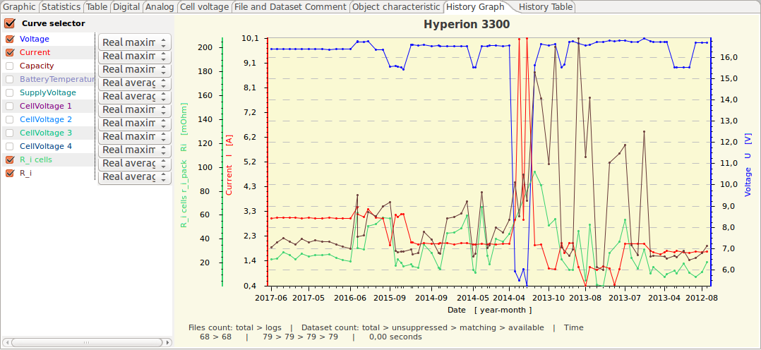
Depending on the selected device and history settings deviations from the shown picture might be possible. The device configuration XML and the actual implementation state will have its influence as well.
The enhanced curve selector enables various statistical values in dependency of the history configuration. It makes sense to store graphics templates for the history analysis view as well, since they hold different values compared to the standard graphics templates.
Additional capabilities of the graphics area context menu:
- load a data set into the graphics view (leftmost tab)
- delete a file (such as log files caused by tests)
- set a file or data set to hidden (e.g. extreme values or outliers)
- toggle hiding ('Selective history')
- interactive analyses via 'Curve survey' in combination with 'Measurement' (see chapter 'Curve Selector Context Menu')
Hint: If a device supports a raw file import (see chapter 'Menu File) it might be possible to include these files into the analysis. This allows you to bypass saving OSD files.

History Table View
The history table view holds equivalent data to the history graphics view. The graphics configuration settings of the graphics view determine the row types and contents in the history table. So this view is intended for a more detailed view of the same data as in the history graphics view. For example, if you make a curve visible in the graphics view and select a curve type like 'standard deviation' for it, the table view will show the exact values for this specific setting.
Hint: Make this tab visible by activating the history in the settings.
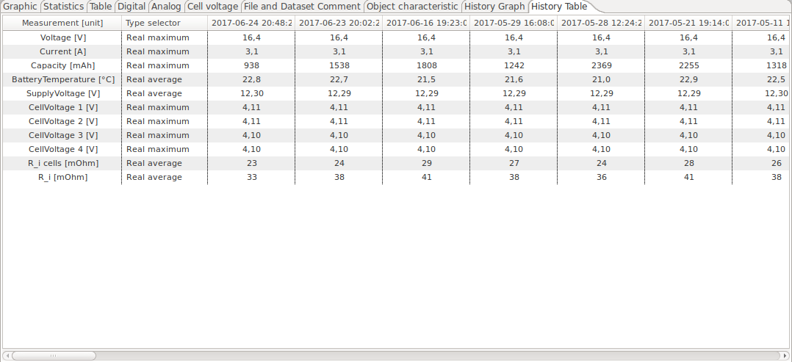
The context menu of the table area is providing analysis matching opportunities.

Device Properties Files
Device properties files are in XML (Extensible Markup Language). Using the XML together with a style sheet (XSD) it is secured to have it validated while reading. If a file is invalid regarding the style sheet it can not be read and will cause an exception. As information material below the actual XSD as picture.

DevicePropertiesEditor
Using the DataExplorer menu bar or started as standalone application it is possible to create new or modify existing device properties files. Doing this the device XML files are touched.
Using the menu bar the device properties file of the actual device will be opened. Is that the case, manipulating properties will not directly manipulate all properties of an already loaded and displayed data set. Will the DevicePropertiesEditor started as standalone application, it is possible to type the name of the device directly, if known. Is the name unknown to the application and can not be find in the devices directory a new device properties file might be created.
A sample files gets extracted and needs to be adapted as required. Selecting the button, right hand side, a dialog will opened to enable selection of an existing file.

The device tabulator shows how to specify name and manufacturer of a device.
Switching the implementation active, the implementing device class name has to be configured, optional as full qualified including the package. The implementation can always used if an equal device implementation class is already available, and/or if the device name does not fit. As an example the CSV2SerialAdapter has several devices using this implementation, differences exist in the data block specification. As additional example the several copies of the Bantam charger devices can be named, where differences exist in cover design and device name. The captured data should be found under the directory followed the device name, isn't it.
If the 'package' is not given, the 'package' gets calculated starting with "gde.device.", followed by the manufacturer name, converted in lower case and hyphen and blanks eliminated. The default class name can be calculated by removing blanks and hyphen. capital letter are kept.
The image name can directly typed if known and it references an existing within the device plug-in. If the image gets selected by use of the right hand side button and file selection dialog the selected image guest scaled to 225×165 pixel. In addition it is possible to pack the image directly into the referenced plug-in. Modifying the plug-in could only done in the temporary folder where write rights are guaranteed. If this option is chosen the modified plug-in must be copied to the application directory, where the plug-in can be added to the class path.
How to do that will be advised in a message box.
Hint: This change might be get lost while updating the application. A backup might be saved somewhere else by your own.
The serial port gets configured easily by selecting appropriate values from the combo boxes.
Hint: If timeouts guest specified the implementation must be written to use this values.
The description of the serial port is optional due to the fact that some devices don't use it. Optional as well is the USB or TCP port definitions.
To configure the time base is simple. A value greater than 0 milli seconds as time step between the measurement points is voted as constant time gap. The time step value lower than 0 milli seconds signals that the device gives individual time steps. This must not mean that the time steps might not constant. The implementation for the particular device must handle this situation.
Hint: The UniLog, as example, uses an adjustable but constant time step between measurement points. Therefore the time step is -1 msec. Finally the device implementation must handle the situation and read the time step value for each sequence and use it as constant value for the data.

The next two pictures contrast two different data block configurations. The UniLog configuration describes binary data with a constant length of 24 bytes. Is 24 bytes the maximum and a shorter length as example 20 bytes possible the configuration must point out -24 as value. The data type is BINARY and no separator sign is configurable.
Is TEXT chosen as data type additionally configuration parameter must be specified. The file extension, what is used during file selection, as well as the standard data path, will help to select files faster. Both are optional, but help, if data files are delivered by a memory card, like the DataVario from WStech, which will appear with a dedicated path value if inserted into the computer.
Hint: This configuration are optional. Other implementation might use this parameters in a different way.

The state tabulator will describe a sequence number to device states. This description makes sense if a device can use more than one state and data are imported by a text file using the CSV2SerialDataAdapter. Finally the device implementation use the states and match it somehow with the data.

Hint: If text data are imported using the CSV2SerialDataAdapter the state 1 would be charge ($1;1;time;data;..), and state 2 discharge ($1;2;time;data;..) compared to the sample.

The tabulator with the name outlet-channel/configuration is the most complex and the biggest one. Here, as required or desired, the device outlet as a data channel or different configurations gets described. As described two different types of outlet-channel/configurations are available. A charger device with only one outlet to connect one battery at a time has only needs to configure only one outlet-channel/configuration from type outlet. The sample on right hand side just showing this.
Underneath the area where the type and the name has to be configured another tabulator describes the individual measurements. The measurement configuration is responsible how the data are finally displayed in the various windows including the unit and the statistic mathematics.

Hint: Is the outlet-channel/configuration type is chosen as configuration (TYPE_CONFIG) different configurations could be combined with identical data set.
If a copy of an outlet-channel/configuration is necessary it is sense full to complete the measurement configuration which belongs together before do the copy.

Measurements get described with the name, its unit, its symbol and if the measurement is active captured from the device. Non active measurements are calculated (current * voltage). In addition there are optional properties like factor, offset and reduction which influence the view of the (raw) data.

Hint: Are additional properties and/or statistics configuration required, use the context menu to create. After a measurement is completely described by properties and statistics it is possible to copy the complete set into a new one using the + button.

Adding a property is simple since there are a lot of prepared once available and only the value needs to be specified.
This statistics sample showing how to select average minimum and maximum as well as how to configure a trigger. A trigger is described by a value and a time to be specified as a limit. All average, minimum, maximum and deviation are related to this trigger now. In addition it is shown how to configure that the time where the trigger is active gets summarized. This might calculate the real motor run-time. It is also possible to count the trigger events.
Hint: It is possible to add comments to the most of trigger or trigger related statistics. This helps to identify which statistic value relates to an adjusted trigger and which not (Statistics Window).
The next sample is showing how an already defined trigger can be used to calculate related statistics data. In the sample, while "sumByTriggerRef" is selected, the height gets summarized over the trigger period only to count the total height by motor run-time. This will help to identify the best propeller to motor adaption in comparison to other combinations.
In addition a proportionality gets calculated to show the used battery capacity versus the height during motor run-time. This allows judgments how effective the available power is used up.
For special purpose integration of measurement values by trigger time is possible while a reference to trigger is given. For example, this enables to calculate power in Wmin.
Hint: Additional configuration samples can be found in UniLog or DataVario device property files.

At least the description follows about the application visualization. At this point it is initially configured which tabulator is active and visible. Active relates to visibility and calculation time for the content to be displayed within the window behind.
Hint: Initial means that the application device selection dialog itself allows to modify this, refer to Device selection dialog.

Data File Format
The file format (*.osd) is implemented in version 1 and version 2 as plain binary format. Increasing data sets and therefore data files actual files are compressed. To enable extensibility for a long time period the configuration data are key value pairs. This enables the capability to keep some configuration data optional similar to optional XML elements. The read functions will construct at first a HashMap of the key/values and apply only the values of existing keys. All other are default. Measurement data point are stored without any change as integer values. This enable to have all data files structure the same, there is no difference between devices.

CSV2SerialAdapter Data Format
The text data format is a standard "Comma Separated Values" CSV-file as it is used by spread sheet applications as well. The alignment of data (values) is common for a lot of battery charger devices. The LogView application also can import this type of data and is named as "OpenFormat". Due to the platform comprehensive approach of the DataExplorer, it is required to make the specification more complete. As example different execution platforms used different new line characters, p.e. Windows <CR><LF> while creating a file. On the other hand it must be secured that files created on different platforms, with specific new line characters, can be interpreted, p.e. GNU/Linux <LF> or Mac OS X <CR>. Refer to the DevicePropertiesEditor data block description.
The sample showing the assignment of the values in relation to the text data and how they gets interpreted.

As pendant data can be send as a JSON string. This looks like this example:
{"dsn":1,"st":1,"tm":0,"data":[1001,1002,1003,1004,1005,1006,1007,1008],"crc":0}
Since the JSON parser relay on the field names, „dsn“ stands for dataset-number, it is important to use this defined names. Otherwise parsing will fail.

Actual Supported Devices
The following will list the actual supported devices with its dialog and give some hints for usage.

AkkuMaster from H-Tronic
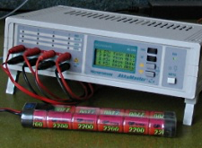
The AkkuMaster C4 device dialog is to be used to view, adjust and gather data from AkkuMaster discharge and charge processes. It is possible to configure each outlet independent from the others. A configuration which overloads the charger is impossible, since the individual loads are accumulated and the resulting total current will be displayed.
Note: If a data gathering process is active, it is not possible to close the dialog. Each outlet channel may gather data in parallel and can be displayed individual. To switch between outlets will not been possible if device dialog is modal adjusted in application preferences.
A lot of hints are available by tool tips of the dialog itself and make this help nearly obsolete. The tool tips are visible by hovering the mouse over the fields of interest.

Version information
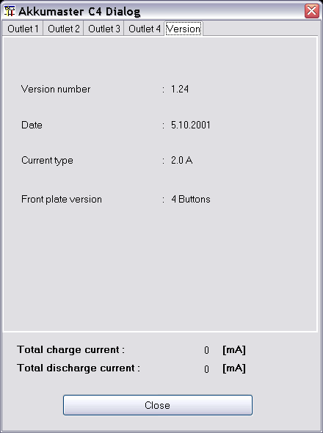
Afterwards the serial communication is configured using the device selection dialog the device version information is gathered in background while opening the dialog. This may lead into serial communication error, if the configured port can't be opened. The device dialog with the actual EPROM version from manufacturer is shown in picture 1 displaying version information.

Configure the data collection
After selecting an outlet tab only the two radio buttons are active. Other senseless buttons are disabled for the moment.
- Gather data only
- Configured process
Such a condition is shown in picture 2.

Gather data only
If, as usual, the charge/discharge process is started at the device, the selection of “Gather data only” the displayed process parameters are updated. Additionally the “Start” button gets activated to enable the start of the gathering process (picture 3).

After the start button is pushed all the graphics displays are updated by the gathering cycle. The stop button gets activated to enable stopping of the process for some cases. New data sets get created while the device switch between charge and discharge. The gathering process stops automatically if the device signals no activity anymore.
Note: Stopping the data gathering process will also stop the running process of the connected device for safety reasons!

Configured processes
While using “Configured process” the data configuring the future process are updated with the actual values depending the current adjusted values of the selected outlet. Afterwards you can modify the values according your choice. Since the program must be loaded into the devices EPROM before it can be executed the adjusted values are written into the selected memory.
Note: Since it is not possible to query data for the selected memory, I prefer to do all program configuration direct at the device and use “Data gather only” for data gathering.
If a memory index will be modified from which is red from the device the background of the combo box is colored the make this change more visible. Such a situation is shown in picture below.

To close the device dialog is only possible while no gathering processes are active. While closing the dialog the serial port is closed as well.

Akkumatik from Estner
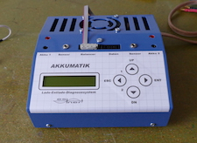
A high quality charging device which is also available as a do it yourself kit. The device supporting reading of data only, it is not possible to store a charge program from outside.

4D-Akkumonitor from epo-bike Racing
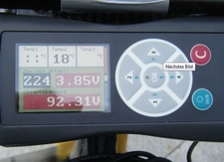
The 4D-Akkumonitor is used to collect data from big battery packs with multiple cells while racing sports. Data gets imported as comma separated files. This files contains beside the cell voltages loop counts and times and GPS data.
The number of log lines per race is not very high, but anyhow the data size itself is height due to the high amount of monitored cells.
More information can be found in Internet.

ArduPilot drone log analyzer


ArduPilot is a project to drive drones. Unfortunately, there are currently no sample files nor assistance from the project. As a result, the implementation is only half finished.

AV4ms (Firmware Version >= 4.67) from Mössinger/MEC
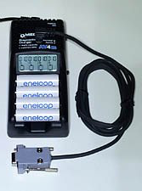
Using the dialog it is possible to adapt measurement names and units. In normal case this should not be required. DataExplorer can read live data through serial connection to the charger. Alternatively it is possible to import textual data, which are gathered by a RS232-data-logger and stored to a USB stick. Using the menu or the import button of this dialog it is possible to import such data.

Hint: Depending on the firmware some channel/configurations might be unused and therefore it does not show curves.


Core-Telemetry

Core-Telemetry Dialog
The below device dialog should be used to configure the visualization of measurements. It is possible to update measurement names and symbols. Even if the measurement units are editable it makes less sense to do without adding a measurement factor in respect to the change. The measurement names and units are contained within the log data and get overwritten while reading. Unchecked measurement will not be displayed. Curves without reasonable data are not displayed either. This will lead to a more clear representation. Curves which are hard to be interpreted in two dimensional way, may be blanked out. As example, if no GPS is connected the GPS relevant curves doesn't get displayed.
It is possible to import data files using the 'open input file' button as well.
The GPS data measurements which are needed to display tracks in Google Earth or to export KMZ/KML do not have a fixed ordinal due to the way the log data are recorded. Latitude, Longitude and the absolute altitude (GPS altitude) are detected as far as possible by naming. While GPS data are available and detected it is possible to load and display such data in Google Earth using KMZ files. This files can be exported using the file menu or directly launched to an installed Google Earth application. How to do so, refer to Toolbar -> Google Earth.
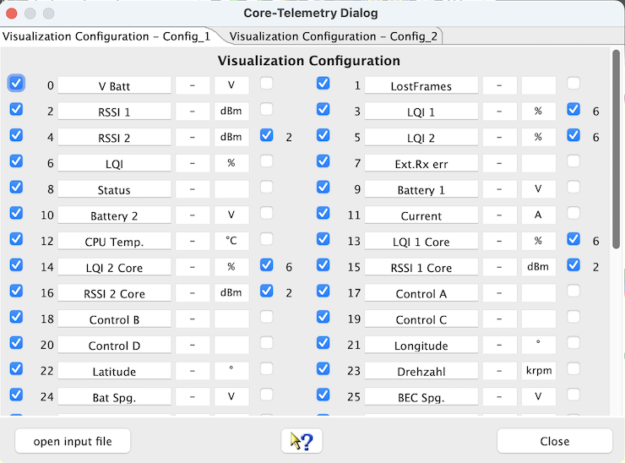
There are two prepared measurement set configurations to be used for different sensor sets. The above screen shot showing the dialog of a loaded log and here you see its reduced to the available measurement set. Using the device properties editor it would be possible to add some more or simply re-name the configuration set, if this is really required.
Hint: To enable a history evaluation, this relies on a constant "sensor imprint", it makes sense to create a separate configuration for each sensor set and to always select this before import in the log files of a model. For this reason it is also necessary to save the imported logs as an OSD file. An OSD file can include multiple logs, such as those from the previous month.
At the right hand side of the configuration panel are check boxes which enable a semi-automatic scale synchronization. While checking measurement name will be compared to previous once and the fitting measurement ordinal will be added to the measurement configuration entry. Using scale synchronization will reduce the required space for scales and spend more for the graphics. Overlaying curves in this matter will allow direct comparison without using the curve compare window.
The names of curves should be unique for this sensor set if possible, sample CurrentMotor, CurrentRx, VoltageMotor, VoltageRx. Please choose the curve names, in case of scale synchronization, in a way that the names starts with the same word, sample Current synchronized to CurrentMotor, CurrentRx, CurrentMotor2. This is the algorithm the semi-automatic synchronization works. Using the DevicePropertiesEditor it is possible to synchronize almost every curve to another by configuration. Sure, this makes only sense for curves where use somehow matching range of values. While the curves and data match it is possible to select the synchronization check boxes.
To archive all capabilities of DataExplorer's statistical calculations refer to Statistic View Window.
Hint: While changing curve names, symbols units or synchronization entries the device configuration file gets changed. With a later version of DataExplorer the device properties schema might change (DeviceProperties_Vxy.xsd), in this case a backup copy of the complete device configurations will be created (Devices_Vxy-1.xsd) and your change will remain there. The out dated device configuration file can be used as template to update the new version.

CSV2SerialAdapter
The device dialog is used to configure the visualization of the displayed data. Using the "open file" button a file selection dialog enable to open new files while applying the current visible visualization configuration. The dialog is build up dynamically and might be different for each device. As example two different dialog are shown:

Hint: The configured visualization profile is also used if a channel/configuration is selected using the tools bar combo box and the data are imported with the "import file" button.

D100 and D100 V2 from SkyRC
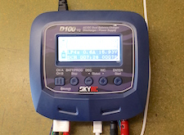
The D100 is a charger with two different independent outlets. With the actual available firmware the previous measured internal resistance will not get transport into the data gathered as it is stated in the manual. A future firmware will possible update this behavior.
The device does not allow to read charge programs instead only reading the data while program execution. This is the reason the device dialog is small and contains only a few sentences.
The switch between charge and discharge or other states get detected by the data gathered. After a few minutes of inactivity the gathering loop will be stopped and the port get closed.
Hint: To charge a set of batteries depending to each other select the D100-Set device instead. This will store both created data sets for each batteries in a single file. Otherwise for each batteries connected to each outlet and captured data set will be stored in individual files.

D200neo from SkyRC
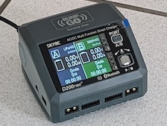
In principle, the same applies as described for the D100. Unfortunately, its use is limited to Linux due to the built-in USB chip. Under Windows or macOS, the USB/Java library used does not recognize the device or its USB port. There is no device dialog, the resistance values of the battery and its temperature are not part of USB output and therefore doesn’t get recorded.

DataVario(Duo) and LinkVario(Duo) from WSTech
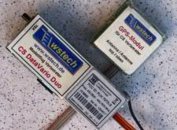
The device dialog is used to configure the visualization of the displayed data. Using the "import data" button a file selection dialog enable to open new files while applying the current visible visualization configuration.
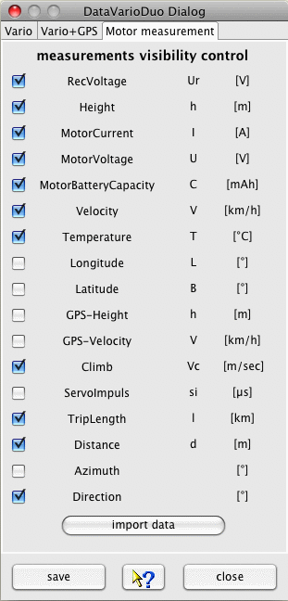
Hint: The configured visualization profile is also used if a configuration is selected using the tools bar combo box and the data are imported with the "import data" button.

Data export in KMZ file format when using a GPS receiver
Using the file menu, File -> Export, it is possible to export GPS based data, if available, in the Google Earth KMZ data format. How to do so, refer to Toolbar -> Google Earth.

VarioTool - manage your setup file
This device plug-in contains an extra tabulators in the main application window. It contains an additional application to create or modify the device specific setup file. This enables this type of application for all DataExplorer supporting operating systems. The tabulator gets created automatically while switching to the device, accordingly it will be removed. As sample the picture below showing the tabulator created for the LinkVario. The application content is adapted to the DataVario as required.
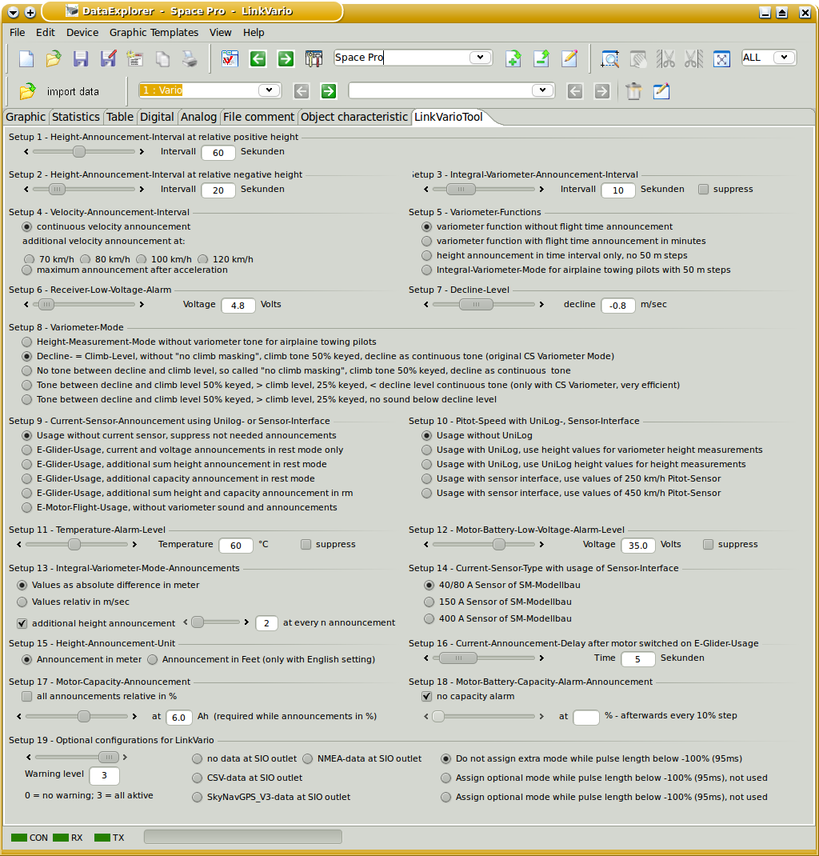

Use the context menu to load and save of the setup file.

eStations from Bantam
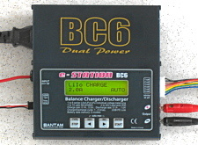
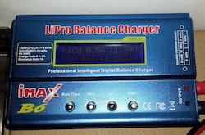
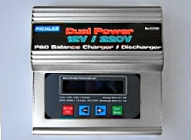
Several cloned devices exist on the market with serial communication port usage. The eStation device dialog is only used to start and stop data collection of charge and discharge processes.

Afterwards the serial communication port adjustments are done using the device selection dialog the start button can be used to initiate data collection.
For NiMh and NiCd batteries the switch from discharge to charge will be done automatically. If the serial communication port signals no data the port will be closed after waiting a few minutes.

FlightRecorder from Multiplex
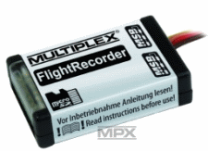
The device dialog should be used to configure the visualization of measurements. It is possible to update measurement names and symbols. Even if the measurement units are editable it makes less sense to do without adding a measurement factor in respect to the change. The units are contained within the log data and get overwritten while reading. Unchecked measurement will not be displayed. This will lead to a more clear representation, curves which are hard to be interpreted in two dimensional way, may be blanked out. It is possible to import data files using the 'import data' button as well.
Curves without reasonable data are not displayed. As example, if no GPS is connected the GPS relevant curves doesn't get displayed. The GPS data measurement values are the once which have a strict alignment to measurement ordinals to enable a check of reasonable GPS data and display export capabilities. While GPS data are available it is possible to load and display such data in Google Earth using KMZ files. This files can be exported using the file menu or directly launched to an installed Google Earth application. How to do so, refer to Toolbar -> Google Earth.
Multiplex sensors are to be configured by addresses, the configured address is displayed as measurement symbol, the units are overtaken. The dialog allows changing the symbols, but this is not required and the symbols are overwritten with the next data import. The measurement names needs to be assigned to have a meaningful association and a differentiation between the measurement curves. If the sensor address keeps unchanged the associated measurement names don't get overwritten. There are already two pre-configured measurement configurations to support different sets of sensors and address associations. Using the device properties editor it would be possible to add some more, if this is really required.
At the right hand side of the configuration panel are check boxes which enable a semi automatic scale synchronization. While checking measurement name will be compared to previous once and the fitting measurement ordinal will be added to the measurement configuration entry. Using scale synchronization will reduce the required space for scales and spend more for the graphics. Overlaying curves in this matter will allow direct comparison without using the curve compare window.
Is is reasonable to think about the sequence and usage of the sensors (sample: Current/Voltage/Capacity - motor battery) before capture data. Afterward adapt and save the configuration without loading data. The names of curves should be unique for this device if possible, sample Current Motor, Current Rx, Voltage Motor, Voltage Rx. Please choose the curve names, in case of scale synchronization, in a way that the names starts with the same word, sample Current synchronized to Current Motor, Current Rx, Current Motor 2. This is the algorithm the semi-automatic synchronization works. Using the DevicePropertiesEditor it is possible to synchronize almost every curve to another by configuration. Sure, this makes only sense for curves where use somehow matching range of values. Now it time to import data and cross check again if the unit, symbol a name matches the requirements. Symbols are optional (Current I [A], Voltage U [V], ...). Do the curves and data match it is possible to select the synchronization check boxes. Finally save the configuration again.
To archive all capabilities of DataExplorer's statistical calculations refer to Statistic View Window.
Hint: While changing curve names, symbols units or synchronization entries the device configuration file gets changed. With a later version of DataExplorer the device properties schema might change (DeviceProperties_Vxy.xsd), in this case a backup copy of the complete device configurations will be created (Devices_Vxy-1) and your change will remain there. The out dated device configuration file can be used as template to update the new version.

Futaba-Telemetry from Robbe/Futaba

Only comma separated files (CSV) can be imported. This files should be placed in the directory …/DataExplorer/Futaba-Telemetry, or the object related directory. The CSV-files only contain English measurement keys in upper case. To enable translation and have a unit a so called mapping file is introduced. The mapping file can be found and edit below directory %AppData%/DataExplorer/Mapping and is named FutabaMeasurementMappings.xml. The content is easy to update if necessary. Only a key and value name for the measurement replacement and unit has to be added. As sample the key CAPACITY should be mapped to Capacity with unit [mAh].
<entry key="CAPACITY">Capacity [mAh]</entry>
<entry key="CH10">Channel 10 [-]</entry>
Please pay attention for equal names and equal units will force a scale synchronization. The name equality respects only the first part of a mapped name until the fist occurrence of an blank character. Using this you can drive which measurement values are using same scale.

GigaLogger from Simprop Electronic
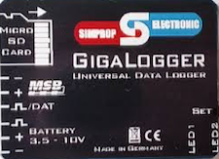
A powerful logger based an Multiplex-Serial-BUS sensors an, writing log data to SD-card. Connect this SD-card using an adapter to your PC to import the log data files for evaluation.
There is no additional device dialog. Anyhow it is possible to replace symbolic names with real meaningful once, the measurement unit can be adapted and scales with identical units can get synchronized. Doing this will need less space for scales and provide more space for graphics.

GPS-Logger, GPS-Logger 2 and GPS-Logger 3 from
SM-Modellbau

The below device dialog should be used to configure the visualization of measurements. Unchecked measurement will not be displayed. This will lead to a more clear representation, curves which are hard to be interpreted in two dimensional way, may be blanked out. It is possible to import NMEA data files using the 'import data' button as well.

Hint: The visualization configuration will be applied as well as it is closed in cases where the tool bar button is used to import the data.
Is an UniLog as sensor device connected the three analog entry fields might be named freely. Same is valid for the symbol. The unit will be overtaken from the NMEA data. As initial presets 'velocity', 'capacity' and 'temperature' gets used. This has to be adapted if required. The scale of the graphics and the curve selector table will display updated names for the measurements. UniLog measurements has always a trailing '_UL'. If required a measurement offset as well as a factor can be configured using the device properties editor.

If Multiplex sensors are connected, the units are overtaken from the NMEA data as well. The names and symbols must be manually adapted. The initial presets are only samples. Multiplex M-Link sensor measurements has always a trailing '_ML'.
At the right hand side of the configuration panel are check boxes which enable a semi automatic scale synchronization. While checking measurement name will be compared to previous once and the fitting measurement ordinal will be added to the measurement configuration entry. Using scale synchronization will reduce the required space for scales and spend more for the graphics. Overlaying curves in this matter will allow direct comparison without using the curve compare window.

Device Setup
The second main tabulator enables loading device setup data from file as well as change and save direct to the SD-card. While switching to the tab the file selection dialog will be opened. As required this can be skipped or repeated.

It is possible to configure a number of alarm thresholds and addresses to be used for Multiplex M-Link sensors.
Hint: A preset directory path is configurable using the device properties editor on tab, Data Block - Optional Entries - data path. This configuration will position the file open dialog at the directory where the NMEA data files can directly be selected at the point where the SD-card is mounted. To load the setup file change into 'SM GPS-Logger setup' directory.
Tip: Since the GPS-Logger stores GPS data it is possible to load and display such data in Google Earth using KMZ files. This files can be exported using the file menu or directly launched to an installed Google Earth application. How to do so, refer to Toolbar -> Google Earth.

GPXAdapter

The device dialog should be used to configure the visualization of measurements. It is possible to update measurement names, symbols and unit. Even if the measurement units are editable it makes less sense to do without adding a measurement factor in respect to the change. The measurement names are contained within the log data and get overwritten while reading. Unchecked measurement will not be displayed. This will lead to a more clear representation, curves which are hard to be interpreted in two dimensional way, may be blanked out. It is possible to import data files using the 'import data' button as well.
Curves without reasonable data are not displayed. The GPS data measurement values are the once which have a strict alignment to measurement ordinals to enable a check of reasonable GPS data and display export capabilities. While GPS data are available it is possible to load and display such data in Google Earth using KMZ files. This files can be exported using the file menu or directly launched to an installed Google Earth application. How to do so, refer to Toolbar -> Google Earth.

GPX files always contain GPS coordinates. Additional, so called, "extensions" are contained optional and are described with names and values, partly comma separated. For extensions we do not have specifications, therefore it is required to complete symbols and units by our own.
There are already two pre-configured measurement configurations to support different sets of sensors and address associations. Using the device properties editor it would be possible to add some more, if this is really required.
At the right hand side of the configuration panel are check boxes which enable a semi automatic scale synchronization. While checking measurement name will be compared to previous once and the fitting measurement ordinal will be added to the measurement configuration entry. Using scale synchronization will reduce the required space for scales and spend more for the graphics. Overlaying curves in this matter will allow direct comparison without using the curve compare window.
Using the DevicePropertiesEditor it is possible to synchronize almost every curve to another by configuration. Sure, this makes only sense for curves where use somehow matching range of values. Now it time to import data and cross check again if the unit, symbol a name matches the requirements. Do the curves and data match it is possible to select the synchronization check boxes. Finally save the configuration.
To archive all capabilities of DataExplorer's statistical calculations refer to Statistic View.
Hint: While changing curve names, symbols units or synchronization entries the device configuration file gets changed. With a later version of DataExplorer the device properties schema might change (DeviceProperties_Vxy.xsd), in this case a backup copy of the complete device configurations will be created (Devices_Vxy-1.xsd) and your change will remain there. The out dated device configuration file can be used as template to update the new version.
Tip: Are there high numbers of extension data contained in the GPX file, for example with Mikrokopter files, there is a capability to map measurement values to different names (translation), mapping of units, adding scale factors, scale synchronization, and so on. Please look up in the text file Mappings/GPXAdapter.properties and change if required. The file can be found below %AppData%/DataExplorer, resp. home-directory/.DataExplorer, resp. home-directory/Library/Application Support/DataExplorer. The content should be self explaining. If the file gets deleted it will be re-created while next initialization of the GPXAdapter.
With an empty GPXAdapter.properties file the configuration will be done exclusively using the device dialog. Take care to have overwritten measurement names, coming from GPX file, but symbols, units and scale synchronization keeps preserved. Since extensions vary in number, name and are not in a defined sequence prefer the way using the GPXAdapter.properties. The number and names in this file doesn't matter. With overlaps in names over several different GPX files the displayed result will always individual for the imported file.

Herkules III Telemetry
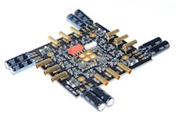
The device represents a specialized solution used as driver for quadro copters and monitor its usage data. The log files following CSV notation and can be imported for visualization. The log data contains driver data as well as batteries data for exact evaluation.
A device dialog enables you to adapt some values, but is not required since the data will be distributed into separate sections.
Each import creating a new dataset with six separate sub data sections.

Hitec RDX1, Hitec X1 Red
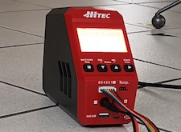

The Hitec chargers are connected as USB HID (Human Interface Device). They are simple chargers, but they meet most requirements.

HoTTAdapter, HoTTAdapter2, HoTTAdapterM, HoTTAdapter2M to analyze reverse channel data of HoTT Graupner/SJ
The device dialog is used to configure the visualization of the displayed data. Using the "import HoTT file" button a file selection dialog enable to open new files while applying the current visible visualization configuration dialog. Start/Stop live data gathering uses the configured serial port. Selecting the Baud rate also selects the used protocol type. 115200 Baud for mx-12(#33112), mx-16(#33116), mx-20(#33124), mc-32(#33032), 19200 Baud for mx-12(#4754), mx-16(#4755), mc-19,22,24(#33300 module, #33301 module, #33302 module). The 19200 Baud protocol has support for legacy V3, as well as new firmware V4.

Hint: Curves will be switched invisible if they contain only zero as data points, even if selected! This might be corrected by re-selecting the curve in this configuration dialog.
Attention: The selected setting Channels at the HoTTAdapter tool box or at HoTTAdapter2 the configuration Channels will read all data, every 10 msec. Packages, where the value of Rx/Tx = 0 dBm get shown. This packages get called back channel lost packages and get displayed in the curve called Rx->Tx-PLoss. The curve exist in HoTTAdapter only while displaying the receiver data. HoTTAdapter2 will display this curve always and only the Rx/Tx curves are influenced. Lost packages doesn't look complete regarding transmitted values and get skipped normally. Channel data are 16 additional time values which get red while this configuration is active, therefore reading of this data may consume more time.
Tip: Since the HoTTAdapter stores GPS data it is possible to load and display such data in Google Earth using KMZ files. This files can be exported using the file menu or directly launched to an installed Google Earth application. How to do so, refer to Toolbar -> Google Earth. Using HoTTAdapter2 all received measurement values are displayed at a single time scale. There are different configurations which result in different statistical analysis for possible measured motor run times and used up batteries capacity.

Using the file transfer tab enables file transfer using the serial connection to the transmitter from and to SD-Card.

- red: shows the creation of model configuration backup files, under a backup-transmitter-type directory, of the transmitter direct out of the transmitter memory.
- blue: using the context menu it is possible to convert model configurations to a different target transmitter type. It is required to check the converted configuration accurate with your target transmitter. Some functions might not supported at the target transmitter due to lack of control emitter, flight phases or different number of curve points.
- green: depending where files are selected the transmit button changes and enable file transfer. Think, we have a serial connection and the transfer takes long time for bigger files.
Hint: Serial communication with transmitter and SD-Card only supported with transmitters using 115200 Baud protocol! Due to the slow transfer rate it is not recommended to transfer big files using this protocol. A lot of time would be consumed executing this and the transmitter might be run out of power.
Hint: Micro-copter GPS Data are stored as decimal degrees (unit of Latitude and Longitude in [°])! For data visualization of Micro-copter data, use the HoTTAdapter with trailing 'M', like Micro-copter.

HoTT-Viewer

Selecting the device HoTT-Viewer it is possible to read files written by the Android application from Graupner HoTT-Viewer created while Bluetooth coupled transmitter session.

The log data are more ore less identical with the data the transmitter is writing as log file as well. But the HoTT-Viewer files are created while direct communication with the transmitter and may deviate some times. This support was implemented to have the opportunity to read such files which can not be read by the HoTT-Viewer application itself.

iCharger206B, iCharger208B, iCharger306B, iCharger3010B and CellLog 8S from Junsi

There is no device dialog for the iChargers as well as for the CellLog 8S. It is only required to establish the serial connection and it will start the gathering live data or start reading data from the device.

Hint: The used Baud rate of 128000 Baud can not be opened if a UNIX derived operating system is used, e.g. Linux or MAC OS X. This data rate doesn't have an even divisor. Linux user will have the opportunity to modify the kernel module source. Hints how to do that can be found in the Internet.

Some iCharger support enables to import device internal saved data. Use the import button. An file selection dialog will be opened. The iCharger must be connected as an USB mass storage device.

iCharger from Junsi using USB connection
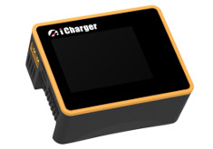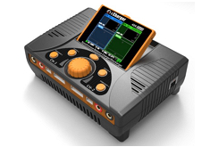
To gather live data USB connection must be established. Check USB HID is detected and configured successful. UNIX derived operating systems may need configuration of udev rules or kernel extensions. While selecting an iCharger with USB at device selection dialog more info get displayed.
The implementation allows, while device has micro SD-card inserted, to import stored execution logs directly. Use menu or "Ctrl+I". A file selection dialog gets opened and enable file selection for import. Requirement is USB mass storage detected by operating system.
Using latest available device firmware (X&S >= 2.0.8, DUO >= 2.19) it is possible to manipulate or create new program memories using a dialog. Use the following device dialog:
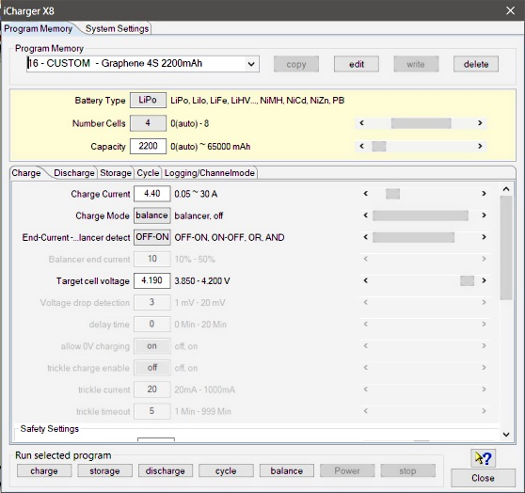
How do I create a new program memory?
- Select a 'BUILD-IN' entry in drop down combo with target battery type and select "copy" button. This will create a new entry with "
- Select the just created program memory and push button "edit" to change the name of the newly created entry to meaningful one.
- Finish editing with pushing 'Enter' button at keyboard. This will change the entry to red outline and mark it as "CHANGED".
- Push button "write" to transfer changed program memory to device.
- Now change all parameter according requirement and push button "write" to transfer changed program memory to device again.
Basically check buttons to be activated, hoover mouse pointer to display tool tips.
- "copy" - copies a 'BUILD_IN' program memory to a 'CUSTOM' program memory with name
- "edit" - enable change name of a selected 'CUSTOM' program memory
(finalize editing with 'Enter' key at key board, normally a drop down combo enables only entry selection)
- "write" - will be activated while detecting name or parameter change and write program memory to device
- "delete" - enable deletion of a selected 'CUSTOM' program memory

To change program parameter there are several possibilities:
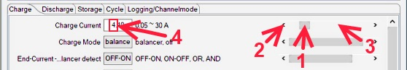
- Select the slider directly and move until target value is reached
- Select end point of slider to change value with minimal step

IGCAdapter to analyze IGC files

There is no IGCAdapter device dialog since there is no configuration required. It targets only the capability to analyze of IGC files prior to upload it while joining a contest. It is possible to analyze four extra values. As example see a log file recorded with GPS-Logger 2 with its “Engine Noise Level” ENL-values.

iMax B6, iMax B6 AC, iMax B6 mini from SkyRC
This device is more ore less a clone from Bantam eStation BC6 or different clones. It will provide data capturing only, connected as USB HID.

IISI Cockpit V2 from Matthias Isler, ESC GmbH
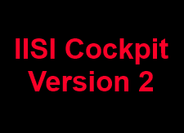
The IISI Cockpit Telemetry is complete independent of the used RC-control system. By the comma separated files (CSV) it is possible to import the data simple and fast.
The first comment line gets added to the data set description. Actual the warnings are also added to the data set description. The complete description can be seen using the tabulator “File- and DataSet Comment”. For example:

IISI-Cockpit V2 - recorded: 2014-06-25, 17:10:06 Version 2.00; Import-Filename: ../DataExplorer/IISI-Cockpit V2/17H07.CSV;
0.0:Model name:TESTLOG1 Batt:3S 5.00Ah TXE Version 2.2 Count flights:100 usage hours:0:00:00
34.0: Alarm Current Reason: 151.0A (100.0A)

JetiAdapter from Jeti Model

The below device dialog should be used to configure the visualization of measurements. It is possible to update measurement names and symbols. Even if the measurement units are editable it makes less sense to do without adding a measurement factor in respect to the change. The measurement names and units are contained within the log data and get overwritten while reading. Unchecked measurement will not be displayed. Curves without reasonable data are not displayed either. This will lead to a more clear representation. Curves which are hard to be interpreted in two dimensional way, may be blanked out. As example, if no GPS is connected the GPS relevant curves doesn't get displayed.
It is possible to import data files using the 'open input file' button as well.
The GPS data measurements which are needed to display tracks in Google Earth or to export KMZ/KML do not have a fixed ordinal due to the way the log data are recorded. Latitude, Longitude and the absolute altitude (GPS altitude) are detected as far as possible by naming. While GPS data are available and detected it is possible to load and display such data in Google Earth using KMZ files. This files can be exported using the file menu or directly launched to an installed Google Earth application. How to do so, refer to Toolbar -> Google Earth.

There are two prepared measurement set configurations to be used for different sensor sets. The above screen shot showing the dialog of a loaded log and here you see its reduced to the available measurement set. Using the device properties editor it would be possible to add some more or simply re-name the configuration set, if this is really required.
Hint: To enable a history evaluation, this relies on a constant "sensor imprint", it makes sense to create a separate configuration for each sensor set and to always select this before import in the log files of a model. For this reason it is also necessary to save the imported logs as an OSD file. An OSD file can include multiple logs, such as those from the previous month.
At the right hand side of the configuration panel are check boxes which enable a semi-automatic scale synchronization. While checking measurement name will be compared to previous once and the fitting measurement ordinal will be added to the measurement configuration entry. Using scale synchronization will reduce the required space for scales and spend more for the graphics. Overlaying curves in this matter will allow direct comparison without using the curve compare window.
The names of curves should be unique for this sensor set if possible, sample CurrentMotor, CurrentRx, VoltageMotor, VoltageRx. Please choose the curve names, in case of scale synchronization, in a way that the names starts with the same word, sample Current synchronized to CurrentMotor, CurrentRx, CurrentMotor2. This is the algorithm the semi-automatic synchronization works. Using the DevicePropertiesEditor it is possible to synchronize almost every curve to another by configuration. Sure, this makes only sense for curves where use somehow matching range of values. While the curves and data match it is possible to select the synchronization check boxes.
To archive all capabilities of DataExplorer's statistical calculations refer to Statistic View.
Hint: While changing curve names, symbols units or synchronization entries the device configuration file gets changed. With a later version of DataExplorer the device properties schema might change (DeviceProperties_Vxy.xsd), in this case a backup copy of the complete device configurations will be created (Devices_Vxy-1.xsd) and your change will remain there. The out dated device configuration file can be used as template to update the new version.

JLog2 from SM-Modellbau
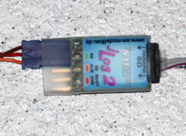
The device dialog should be used to configure the visualization of measurements by selection. Names can be changed as well as symbols and if necessary the unit. Unchecked measurement will not be displayed. Curves without reasonable data doesn't get displayed as well. This will lead to a more clear representation, curves which are hard to be interpreted in two dimensional way, may be blanked out. It is possible to import data files using the 'import *.txt files' button as well.

Hint: The visualization configuration will be applied as well as it is closed in cases where the tool bar button is used to import the data.
At the right hand side of the configuration panel are check boxes which enable a semi automatic scale synchronization. While checking measurement name will be compared to previous once and the fitting measurement ordinal will be added to the measurement configuration entry. Using scale synchronization will reduce the required space for scales and spend more for the graphics. Anyhow, keep in mind that this has influence to the curve and scale visualization and may corrupt this as well. Overlaying curves in this matter will allow direct comparison without using the curve compare window. The visualization is prepared to minimize required changes.
Please choose the curve names, in case of scale synchronization, in a way that the names starts with the same word, sample Current synchronized to Current Motor, Current Rx, Current Motor2. This is the algorithm the semi-automatic synchronization is working. Using the DevicePropertiesEditor it is possible to synchronize almost every curve to another by configuration. Sure, this makes only sense for curves where use somehow matching range of values.

In cases where other sensors get connected it might be required to adapt a measurement factor or add an offset to adapt sensor capabilities to reality. All this can be done by using the DevicePropertiesEditor.
Hint: While changing curve names, symbols units or synchronization entries the device configuration file gets changed. With a later version of DataExplorer the device properties schema might change (DeviceProperties_Vxy.xsd), in this case a backup copy of the complete device configurations will be created (Devices_Vxy-1) and your change will remain there. The out dated device configuration file can be used as template to update the new version. If a device configuration file seams to be damaged, just delete it from Devices directory. It will be recreated next time DataExplorer gets started.

JLog2 Live Data Gathering
While the data gets created it is possible to gather them. As prerequisite a serial port must be configured for the JLog in this application. Is this done and the USB FTDI interface for serial communication is connected to the system and with JLog2 the live data gathering can be started immediately by push the start live data button. The application waits until data can be received and display it as possible. Important is to have the JLog2 and the connected Jive motor driver connected with a battery to enable motor activation. Otherwise JLog2 will not start its own logging. Writing log data to the SD card can not be suppressed.

JLog2 Configuration
While selecting the configuration tabulator of this dialog a file open dialog gets opened to select a CONFIG.txt file. This file is located in the root directory of the SD card. This file will be red and the contained configuration displayed in the dialog.
After changing some configuration values saving changes will be enabled. The CONFIG.txt file should be written to identical location as red before. Afterward the SD card can be removed from the system and inserted into the slot of the JLog2.
While using sub devices which provides data integrated into the JLog2 data log this sub devices needs to be connected properly and configured as required. As example the GPS-Logger or a battery BID chip should be named.

JLog2 and Telemetry
It is required to configure the telemetry configurations fitting to the connects sub device. According to the description telemetry data get requested by the receiver and transmitted to the radio controller.

JLog2 and HiTec Telemetry
The receiver and JLog2 has to be connected as shown to enable HiTec telemetry. Keep in mind to have pull-up resistors, otherwise the receiver do not accept data as telemetry data bus.

Hint: It is not possible to connect additional analog sensors, only the COM connector enables connection of digital temperature sensors!

JLog2 and HiTec Telemetry and Digital Temperature Sensors at COM connector

JLog2 and HV2BEC, HiTec Telemetry and Digital Temperature Sensors at COM connector

Hint: If a HV2BEC is configured and connected the external temperature changes to HV2BEC temperature, external temperature 2 to external temperature 1 .... external temperature 5 to external temperature 4!

JLog2 and GPS-Logger
Using the GPS-Logger as sub device it is required to configure Multplex addresses to enable the communication of JLog2 and GPS-Logger.
- No telemetry: Speed at address 14 and Altitude at address 15
- HiTec telemetry: Speed at address 14 and Altitude at address 15, Vario at 13, Distance at 12, TripLength at 11 and Direction at address 10
- Multiplex telemetry: Do not use address 2 and 3 by JLog for a sensor! The Multiplex receiver should not be configured for voltage and LQI to send on the BUS. The GPS-Logger needs to be configured to have Speed at address 2 and Altitude at address 3.
- Multiplex telemetry with LQI: Do not use address 1 by JLog. On the other hand the Multiplex receiver LQI address needs to be set to 1. While configuring the receiver take care do not interfere with addresses, especially voltage, but voltage should be configured to a free address.

JLog2 Robbe/Futaba BID Chip
To connect a battery BID Chip as sub device take care for correct connection.

JLog2 and 2 Sensors (Pulse Per Revolution, Temperature)

JLog2 and 2 Alarm Lines

For additional hints refer to JLog Connections

Kosmik from Kontronik
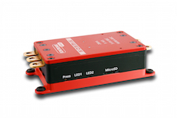
The device dialog should be used to configure the visualization of measurements by selection. Names can be changed as well as symbols and if necessary the unit. Unchecked measurement will not be displayed. Curves without reasonable data doesn't get displayed as well. This will lead to a more clear representation, curves which are hard to be interpreted in two dimensional way, may be blanked out. It is possible to import data files using the 'import data files' button as well.
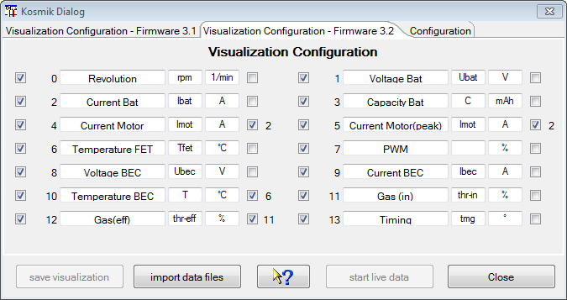
Hint: The visualization configuration will be applied as well as it is closed in cases where the tool bar button is used to import the data.
At the right hand side of the configuration panel are check boxes which enable a semi automatic scale synchronization. While checking measurement name will be compared to previous once and the fitting measurement ordinal will be added to the measurement configuration entry. Using scale synchronization will reduce the required space for scales and spend more for the graphics. Anyhow, keep in mind that this has influence to the curve a scale visualization and may corrupt this as well. Overlaying curves in this matter will allow direct comparison without using the curve compare window. The visualization is prepared to minimize required changes. Please choose the curve names, in case of scale synchronization, in a way that the names starts with the same word, sample Current synchronized to Current Motor, Current Rx, Current Motor2. This is the algorithm the semi-automatic synchronization is working. Using the DevicePropertiesEditor it is possible to synchronize almost every curve to another by configuration. Sure, this makes only sense for curves where use somehow matching range of values.
Hint: While changing curve names, symbols units or synchronization entries the device configuration file gets changed. With a later version of DataExplorer the device properties schema might change (DeviceProperties_Vxy.xsd), in this case a backup copy of the complete device configurations will be created (Devices_Vxy-1) and your change will remain there. The out dated device configuration file can be used as template to update the new version. If a device configuration file seams to be damaged, just delete it from Devices directory. It will be recreated next time DataExplorer gets started.
Revolution values are given normalized to a two poles motor. To adjust display values it is required to configure a factor using the selected motor poles and/or gear ratio. In cases where other sensors get connected it might be required to adapt a measurement factor or add an offset to adapt sensor capabilities to reality. All this can be done by using the DevicePropertiesEditor.
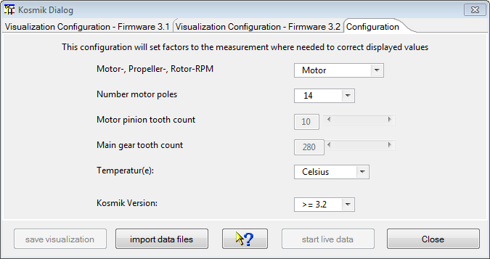
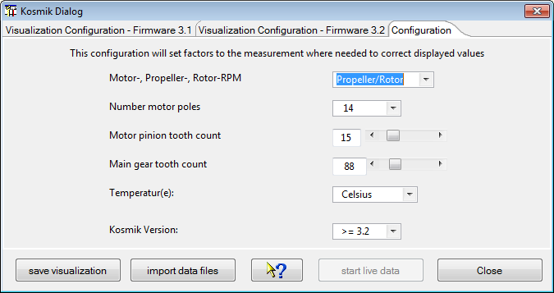
Additionally temperature unit can be adjusted to Fahrenheit instead of Celsius degrees.

LiPoWatch from SM-Modellbau
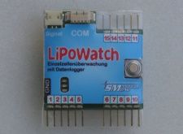
The LiPoWatch device dialog is to be used to visualize and adjust of the LiPoWatch "Settings". Using the last tabulator "Data I/O" the data stored in the device can be read and visualized.

A lot of hints are available by tool tips of the dialog itself and make this help nearly obsolete. The tool tips are visible by hovering the mouse over the fields of interest.
The actual implementation fits the firmware version 1.0.

Tabulator „Configuration“
Afterwards the serial communication is configured using the device selection dialog and the device dialog is opened it is possible to query the LiPoWatch internal setting by pushing the button “Read Configuration”. Such a view with queried settings is shown in picture 1.

If configuration settings are modified the button “Save Configuration” gets activated. Pushing this buttons will write the modified settings data into the LiPoWatch device.
Hint: It is meaningful to read at first LiPoWatch configuration before modifying, otherwise some dialog defaults will be written into the device.

Tabulator „Data I/O“
Initially all buttons are active to read log data from the LiPoWatch.

After pushing “Start data gathering” all the data within the device gets red.
The live data visualization is not yet implemented!
By pushing start* buttons as reaction the stop* buttons are getting activated.

At the end of the read operation the data are displayed. The dialog gets back to its initial state. Only the progress bar is filled and the number of red measurements are displayed.

MC3000 from SkyRC
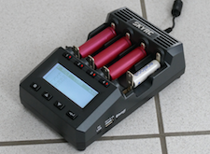
There are three device descriptions for the SkyRC MC3000.
A MC3000-Set is storing all collected data sets in a single file. The result is a continuous recording. This will help to keep track of the slot to data set relation. In the case of four simultaneously charged batteries, a data record is obtained for each cell and all data records are saved in one file. The combined data set with the most important values is also saved and makes it easier to compare the cells in the set.
The MC3000_FM_NiMH_LiIo only records the combined data set continuously and provides two special graphic templates, as can be seen from its name.
A MC3000 treat each slot independent of the other. Each slot has a separate sequence of record sets. This will result in one file for each slot and battery since each battery does not have a relation to the others. A separate data set can also be saved for the combined data set if required.
Note: To ensure continuous recording, make sure that the computer does not go into standby or sleep mode. This will stop the recording and there will be steps in the display of the curves.

Device Dialog
The device dialog enables the user to configure the four slots with temporary programs (set) which were once stored programs on the device themselves and subsequently backed up with this very dialog. It makes sense to make a backup of the device programs because they can get overwritten by other users or erased by a device reset or a firmware update. DataExplorer automatically creates an internal database allocating up to 30 spots for memorizing or backing up device programs, which are likewise automatically available in a direct manner as soon as the device dialog is launched (read all). Most of the widgets in this dialog have a tool tip to help the user understand their functionality.
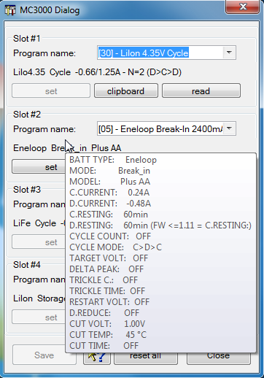
For every slot, the most essential parameters of the program which is currently available to the user are displayed in short form below the drop-down menu. He then can assign this program to one of the 30 backup spots and also rename it along the way, or transfer it for the temporary overwriting in the slot (set), or simply have a detailed look at the complete set of program settings. The latter, the detail list, can be viewed in form of a tool tip, whenever the mouse pointer hovers over that short form. Or, it can also be copied to the clipboard (clipboard). By pasting clipboard contents systematically into a separate text file, one could build one's own database of programs and supplement it with more detailed titles and descriptions for personal use. For the renaming or description of the programs to be stored, up to 35 characters can be used. After entering new program titles, one should not forget to save the changes (Save). It certainly is useful and sensible for one's own organization to assign the very same program number in the database under which the program was saved on the device.
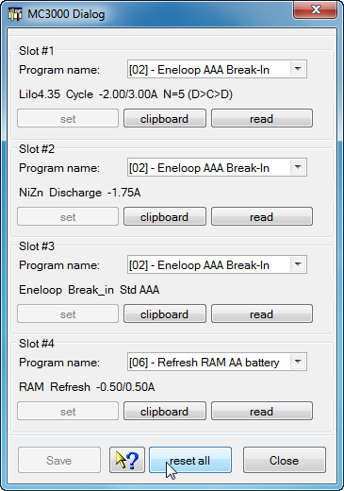
Note: The (reset all) button will retrieve the initial program settings, which were loaded automatically upon launching the dialog, and also transfer them back to the slots (set). In general, it is hard to make out whether a particular program has been transferred to the slot successfully indeed. After the transfer one could see bits and pieces of the temporary program, possibly a short form depending on the device settings, if the battery was already inserted in the respective slot (ready slot). A complete visual check of the transferred program settings can be done through this dialog only (clipboard). To gain a better overview the tool tip is shorten in respect of the not changeable parameters compared to the clipboard. Unfortunately, on the device itself, there is not another possibility of a complete check. After closing the dialog (Close), it is the user's responsibility to insert the correct batteries matching the program settings in the slots, before starting the program and the data capturing (Start gathering). Once the programs have started running, the device would display the operation of the slots as usual.

NMEA-Adapter

The device dialog is used to configure the visualization of the displayed data. Using the "import NMEA file" button a file selection dialog enable to open new files while applying the current visible visualization configuration dialog.

Configuring the time delta to UTC the position related time zone difference can be adapted.
Hint: Curves will be switched invisible if they contain only zero as data points, even if selected! This might be corrected by re-selecting the curve in this configuration dialog.
Tip: Since the NMEA-Adapter stores GPS data it is possible to load and display such data in Google Earth using KMZ files. This files can be exported using the file menu or directly launched to an installed Google Earth application. How to do so, refer to Toolbar -> Google Earth.

OpenTX-Telemetrie used by FrSky System

OpenTX a open source system providing telemetry data analysis support. Data files can be imported and get prepared for visualization. The data containing measurement names and sometime units. To complete this for your evaluation a mapping file, OpenTxMeasurementMappings.xml, can be used. Please follow the sample section:
<entry key="Long">Longitude [°']</entry>
<entry key="Lat">Latitude [°']</entry>
<entry key="Course">Course [°]</entry>
<entry key="GPS Speed">GPS Speed [km/h]</entry>
<entry key="GPS Alt">GPS Altitude [m]</entry>
<entry key="Baro Alt">Altitude [m]</entry>
<entry key="Vertical Speed">Climb [m/sec]</entry>
<entry key="Air Speed">Air Speed [km/h]</entry>
<entry key="Temp1">Temperature 1 [°C]</entry>
<entry key="Temp2">Temperature 2 [°C]</entry>
<entry key="RPM">Revolution [1/min]</entry>
<entry key="Fuel">Fuel [%]</entry>

PichlerP6, PichlerP6 50W, PichlerP6 80W from Pichler
This charging devices are more or less clones of the eStation BC6 from Bantam or derivates. Only data gathering is possible.

Picolario from Renschler
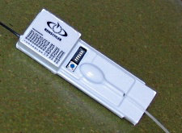
The Picolario device dialog is used to read logged data out of the device. For later data visualization adaption the two inner tabulators enables data configuration according your needs. Depending of the available data the configuration requires more or less adaption. For adjustment the following options can be used:
- Leave height values untouched
- Subtract first height value from subsequent (it's the normal case)
- Subtract last height value from preceding (late start of data logging)
- Height offset
- Slope calculation type
A lot of hints are available by tool tips of the dialog itself and make this help nearly obsolete. The tool tips are visible by hovering the mouse over the fields of interest.

Afterwards the serial communication is configured using the device selection dialog and this dialog is opened, the only active button „Read number records“ must be pushed to read the actual available record number from the device (prerequisite is the Picolario is ready to transfer data). A sample result is shown in picture 1.

In the second step it is possible to adjust the data configuration using one of the inner tabs. The visible tab will be used to manipulate data for visualization of the current red data. Normally a good choice is what is stored as default. If any further adjustment is required it can be done after reading the data.
As third step each single data set can read one after the other by select the record number and push the „Read selected record“. A better method is to read all the data in series. Depending the amount of data this can take a time. It is possible to display each data set in the display right after finishing read operation. To achieve this behavior the check box „Display data set right after read finished“ must be checked. To view and manipulate red data sets it is good to set the device dialog not in application modal mode (application preferences).

An active device dialog is shown in next picture.

Configuration Tabulators
As mentioned in the introduction section the visualization of the data can be adapted as required. Do the height values require an offset of an amount what is not offered be combo selection a manual overwriting of the entry is possible.
The slope calculation might be performed using different algorithm and time intervals. A linear regression results in better smoothed curve, but as drawback a phase shift against the height curve can be recognized. This drawback is eliminated by using the none linear variant of the regression calculation, to simplify it's called „curve“.
To get the slope value at a point of interest it is possible to measure it by context menu selection Curve Selector -> Height -> Context menu -> Point difference.
Mainly two variants of curve adaption takes place in the daily usage. This is the reason to have the two inner tabulators to adjust the two configuration types independent.
To permanent use the other adjusted configuration tab values it is possible to shift the data set to use the other configuration tab. Therefor simply select the different tab according the channel configuration selector (the different one which is displayed in front after opening the dialog). The application ask if you really want to do this and shows the following message box.

If the answer is yes, the data set uses the new configuration values of the selected tabs.
Note: After each display configuration change the visual data are adapted to be displayed using the new values. If new values should be used as defaults for the next data gathering operation the configuration adjustment can be made persistent by pushing the „Persist settings as defaults“.
The height can be displayed in feet by adapting the following in the Picolario.xml device configuration file from
<Property description="Height calculation Feet to Meter (1852 / 6076)" type="Double" value="0.304806" name="factor"/> to
<Property description="Height calculation Feet to Meter (1852 / 6076)" type="Double" value="1.0" name="factor"/>
and the section where the unit is given from
<unit>m</unit> to <unit>feet</unit>.
The file can be found in application configurations directory under ../Devices/Picolario.xml.
The main sense of the configuration tabs will focus on the statistic data. This is the reason the tabs are re-named to "Thermal" and "Motor". Using the motor configuration it is tried to filter the parts where a running motor can be assumed. The statistic values focus on the filtered areas (refer to the screen shots as example).

Later it is planned, to enable modification of the values needed for the statistic calculation by the dialog.

Picolario2 from Renschler

The device dialog should be used to configure the visualization of measurements. It is possible to update measurement names and symbols. Even if the measurement units are editable it makes less sense to do without adding a measurement factor in respect to the change. Unchecked measurement will not be displayed. This will lead to a more clear representation, curves which are hard to be interpreted in two dimensional way, may be blanked out. It is possible to import data files using the 'import P2L data files' button as well. Curves without reasonable data are not displayed. As example, if no GPS is connected the GPS relevant curves doesn't get displayed. The GPS data measurement values are the once which have a strict alignment to measurement ordinals to enable a check of reasonable GPS data and display export capabilities. While GPS data are available it is possible to load and display such data in Google Earth using KMZ files. This files can be exported using the file menu or directly launched to an installed Google Earth application. How to do so, refer to Toolbar -> Google Earth.
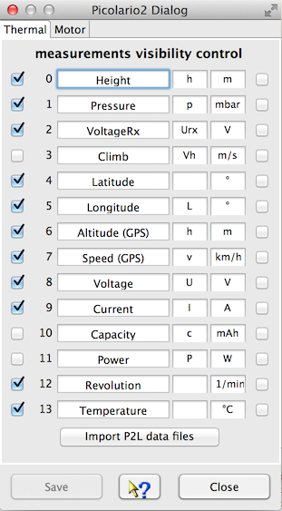
At the right hand side of the configuration panel are check boxes which enable a semi automatic scale synchronization. While checking measurement name will be compared to previous once and the fitting measurement ordinal will be added to the measurement configuration entry. Using scale synchronization will reduce the required space for scales and spend more for the graphics. Overlaying curves in this matter will allow direct comparison without using the curve compare window.
Hint: While changing curve names, symbols units or synchronization entries the device configuration file gets changed. With a later version of DataExplorer the device properties schema might change (DeviceProperties_Vxy.xsd), in this case a backup copy of the complete device configurations will be created (Devices_Vxy-1.xsd) and your change will remain there. The out dated device configuration file can be used as template to update the new version.

Polaron Charger from Graupner/SJ
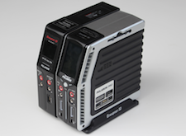
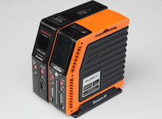
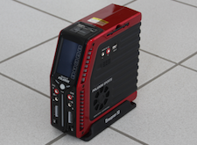

All Polaron charger do not need a device dialog. After configuring the serial port just start live gathering the charging curves.

Power Peak from Robbe
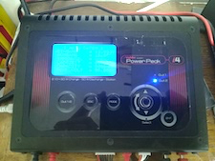

A powerful charger with simple operation, live data acquisition via a serial connection.
There is no device dialog.

Q200 from SkyRC
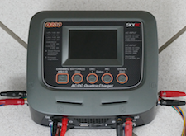
The Q200 is a charger with four different independent outlets. With the actual available firmware the previous measured internal resistance will be transported into the data gathered as it is stated in the manual.
The device does not allow to read charge programs instead only reading the data while program execution. This is the reason the device dialog is small and contains only a few sentences.
The switch between charge and discharge or other states get detected by the data gathered. After a few minutes of inactivity the gathering loop will be stopped and the port get closed.
Hint: To charge a set of batteries depending to each other select the Q200-Set device instead. This will store both created data sets for each batteries in a single file. Otherwise for each batteries connected to each outlet and captured data set will be stored in individual files.

QuadroControl for QC-Copters from tt-tronix

The device dialog is used to configure or synchronize the radio control to the QuadroControl. Instructions are displayed within the terminal window.

The displayed tabulator of the dialog is used to configure the visualization of the displayed data. Not checked curves get suppressed during visualization. Changes of this configuration can be saved and is used for all follow on visualizations.

Hint: To keep the overview of displayed curves while gathering, curves will be switched invisible if they contain only zero as data points, even if selected!

S32 (Jlog3) from R2prototyping
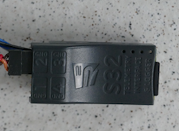
The S32 is the successor of the legendary Jlog2.*, but internally there is a dramatically change. The S32 is a multi talent regarding connectivity and extensibility. Using an extension up to 16 cell voltages can be monitored. To configure the S32 you need a micro USB cable and a Windows PC. Due to the complexity of the configuration, comparable to an expert system including firmware update, this program will not be ported to different operating systems.
The S32 log data get written in OpenFormat CSV notation and needs to be imported for evaluation purpose.
For more information visit http://j-log.eu/s32/s32-en/

Spektrum-Telemetry


After selecting the spectrum telemetry you can import TLM files. The flights contained therein are analyzed and only the recordings that are longer than 3 minutes are evaluated and displayed.
Note: After selecting the "Vario + ESC" configuration and then importing it, it is calculated how many vertical meters have been reached with the motor current and then related to the capacity used.
Hint: After selecting SpektrumCSV, you can import CSV files from TLM files.

Simulator
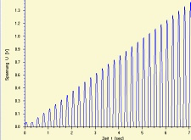
The Simulator device dialog is used to create synthetic data for several test cases. There is no effort spend to make this nice, it is only function required. The functionality can adapter according needs.

Ultramat, Ultra Duo Plus, Ultra Trio Plus from Graupner

Only Ultra Duo Plus devices are capable to manage battery memories and charge and discharge parameters. Ultramat and Ultra Trio Plus devices do not need a dialog.

Ultra Duo Plus Device Dialog Introduction
With the Ultra Duo Plus device dialog you are able to configure device identification name, button sound, etc.. The main configuration tasks are the naming from battery memories and its battery type, capacity and charge, discharge and cycle parameter (excluding the Ultra Duo Plus 80).
If the serial communication port is selected using the device selection dialog, the port will be automatically opened while opening the dialog and some configuration data will be gathered from the device. To select the battery memories the drop down gets used. The adjustment of the parameter values can be done by using the slider on right hand side or when value field has white background by typing.

Hint: It is important to specify a device identifier name. Since this name is used as identifier for a data cache. The data cache gets created during first opening of the configuration dialog. Therefore the first open takes a few seconds longer than afterward. If the cache is filled and in sync with the device data can be seen by activating the backup/restore buttons.

The following pictures displays charge, discharge and cycle parameters for a NiMh sample battery.

The following picture displays the step charge parameters tabulator, which is only enabled for a NiMH battery.
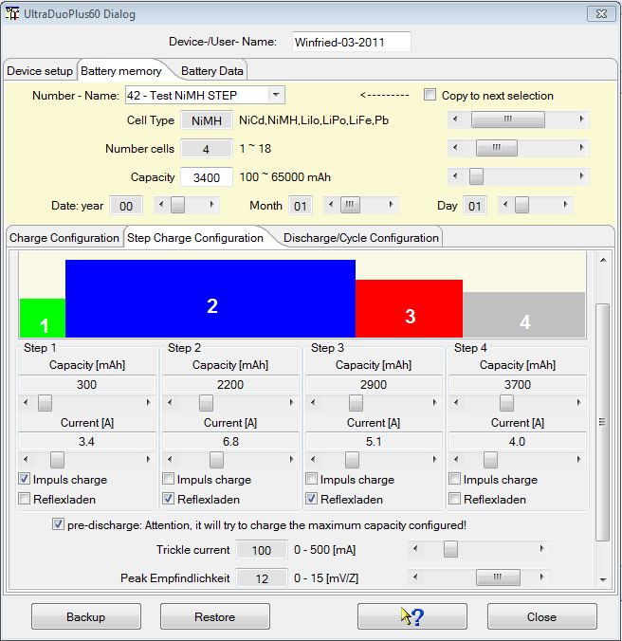
The following pictures displays charge, discharge and cycle parameters for a LiPo sample battery.

Hint: Only parameters gets displayed for configuration purpose which has a relevance for the selected cell type. The configuration of step charge parameters are actually not possible and is part of future release.

Data gathering
To start data capturing simply push the "start gathering" button. Do this while the charger is prepared, charge process configured, battery connected. Right after starting the gathering process at the DataExplorer start the charge process at device. Only this sequence guarantees that the complete charging process gets captured. Switching between charge, discharge and other curve types is enabled automatically by values received from the device. While a new curve gets created the graphical visualization switches to this data set at the certain outlet data channel. The picture below showing a graph of a linked charged LiPo battery with 8 cells. Only curves gets displayed which contain data. Therefore there is a skip in CellVoltage numbers between 4 and 8. This relates to the balancer outlets where the batteries are connected.

If the device is inactive for a certain time frame the serial communication port gets closed.

Automatic Object Selection
Charging devices which are capable to manage battery memories forwards this possibility to automatic object key selection.
As pre-requisite the configuration dialog must be used to configure the battery memories. During the configuration activity a configuration file gets created and is used as data cache. The configured device name is part of the file identifier. While the data gathering gets started the device identifier name will be read. Afterwards the normal gathering will begin. Receiving the first data from the device, the process memory number is known. With the battery memory number the memory name can be looked up. The battery name is now used to find a best match from object key list. If a good match can be found the object key gets selected while creating the first data set.
How to match the object name while there is no complete containment ?
The battery memory name gets split at blank, hyphen and under bar. The name fragments are now used to find partially matches. The object name which has the most containment hits get selected.

Hint: To have good matching results, name battery memories as well as object key names accordingly. Both names battery memory name as well as object key name can be renamed if required

Battery Cycle Data History
Using the Battery Data tab of the UltraDuoPlus dialog it is possible to query battery history data, cycle data. Doing this result in a new utility graphics tab, called Battery History, in the main application window.

Hint: Only data gets displayed which are taken within the last two years of the selected battery memory.

Through device date miss adjustment it is possible to collect wrong data in respect of time stamp. If such a time stamp will be detected a small dialog gets opened to enable correction.

How it is possible to correlate such entries regarding the time stamps? Just skip all the correction dialog and have a brief look at the table which now contains all the entries red from device.

Using saved DataExplorer files of the selected battery, statistics tab, you will find which entries have a mismatch. Afterwards just run the history query again and correct the entries where a matching file was found.

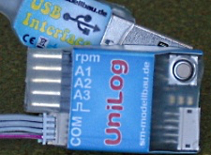
UniLog from SM-Modellbau

The UniLog device dialog is to be used to visualize and adjust of the UniLog "Settings". Using the last tabulator "Data I/O" the data stored in the device can be read and visualized. To manipulate the visualization the four configuration tabs might be used. At this place everybody can create there own configuration with meaningful names. In initial, as recommendation, there are
- Height, simple height measurement with low additional weight for the model plane
- Receiver, additional to the height the receiver supply power can be measured to get reasonable values to estimate required power consumption for the voltage regulator
- Motor, to measure the motor power and efficiency to dimension the motor controller or propeller
- Velocity, influence of the prop to the flight velocity or simple get a feeling for the planes speed
Alternative the configurations can be adjusted to fit personal requirements or simply model names like Model_1 to Model_4.
A lot of hints are available by tool tips of the dialog itself and make this help nearly obsolete. The tool tips are visible by hovering the mouse over the fields of interest.
The actual implementation fits the firmware version 1.10.

Tabulator „Settings“
Afterwards the serial communication is configured using the device selection dialog and the device dialog is opened it is possible to query the UniLog internal setting by pushing the button “Read UniLog settings”. Such a view with queried settings is shown in picture 1.

All analog outlets are to be pre-configured starting with firmware 1.10. By activating the limiter function the signal to the motor controller are reduced reaching the adjusted consumed energy. To enable this functionality the controller signal must go through the UniLog. An activated limiter will also set the time step to 1/16 Second and only one data collection is possible.
If settings are modified the button “”Write UniLog settings” gets activated. Pushing this buttons will write the modified settings data into the UniLog device.
Hint: It is meaningful to read at first UniLog setting before modifying, otherwise some dialog defaults will be written into the device.

Tabulator „Data I/O“
Initially all buttons are active to read log data from the UniLog. With selecting a specific configuration, tabs 2 to 5 will be explained next section, this selected configuration will be applied to the red data. But it is possible to switch data configurations later for each data set individual.
Only the “delete” button is extra. Pushing this button the data are marked for deletion. The deletion gets active next time a log operation is started. The data stored within can still be read.

After pushing “Start reading data” all the data within the device are going to be red and the read operation starts immediately and the selected configuration is applied.
Using the button “Start live data recording” a query cycle is initiated which reads according the device settings and connected sensors and the data are displayed in graphics, as digital and as analog displays. If the button “Start” within the UniLog data recording group is pushed the UniLog itself will log the data internal.
By pushing start* buttons as reaction the stop* buttons are getting activated.

At the end of the read operation the data are displayed. The dialog gets back to its initial state. Only the progress bar is filled and the number of red data telegrams are displayed.

The Data I/O Tabulator enables to modify the configuration names. To change a configuration name it is required to push at first the button “Change name” to activate the change mode. After editing the name the operation is committed by the enter button. The new name will be displayed in the tabulator changed and will made persistent in the device configuration file.

Tabulator Configuration
This complex tabulator is showing all device possible measurements. Only the real measurements representing a device sensor connection has a check box to enable activation. If a measurement gets activated the depended measurements are getting activated too. As sample the receiver configuration tab will be explained.

If the measurement “Height” will be selected the dependent measurement slope calculation with its two combo boxes gets activated.
For the slope calculation one of two regression types has to be selected as well a regression interval time between 1 and 20 seconds.
Each change will be immediate change the data set visualization. A change will also activate the “Persist adjustments as default” button to make the configuration composition persistent and will be used next time data are gets applied to this configuration.
Special are the 3 analog connectors (A1 to A3). All analog outlets are pre-configured using the device settings (Settings tab). This will adjust UniLog internal measurement adjustment. While reading data this UniLog internal settings are used to adjust name and unit for each analog measurement. If required for the connected sensor an offset as well as a factor can be used for adaption. A change will activate the “Persist adjustments as default” button to enable to persist the change for later repeated usage.
If a data set is just displayed while opening the dialog the dialog tab with the matching configuration is displayed on top. Does the data set displayed not match the configuration the configuration might be adapted or a better matching configuration selecting another tab can be selected. By doing this a message box pops up to commit or de-commit this operation.

Different configurations enable different statistics data calculation. As sample the next screen shot displays a receiver configuration statistics view.

Below a motor measurement statistics view is displayed. All important calculation data and differences are red circled.

For later it is planned to enable the adaption of the statistic configuration by a dialog.
Hint: If four configurations are to much it can be reduced. This requires to comment out channel configuration in UniLog.xml (<!-- XML comment -->). More then four configurations are possible but the current implementation does not support.
Of course it is possible to activate all measurements in the configuration tab and filter using the curve selector.

Tabulator „Telemetry“
Using this tab it is possible to adjust all telemetry relevant configurations which are supported by the transmitter/receiver systems involved. Actual supported transmitter/receiver systems are Jeti Duplex, Futaba and Multiplex M-Link, since UniLog firmware level 1.12. At first the actual UniLog configuration should be red and afterwords, with help of the transmitter/receiver systems manual, change the configuration as required.

While a configuration will be changed, the button to write the updated configuration into the UniLog, will be enabled.

UniLog2 from SM-Modellbau

The device dialog should be used to configure the visualization of measurements. Unchecked measurement will not be displayed.
There are two different data set configurations. This configurations are used for statistics calculations only. Only the Motor type configuration contains current level trigger to measure the motor runtime and calculate the reached height. For the climb flights used battery capacity is required to calculate a reference value of the needed capacity per height meter. While loading the data the actual selected configuration will be used to display and calculate statistics. It is possible to move the data to the other configuration with opened dialog and selecting the different configuration tab.
It is possible to import log data files using the 'import data' button as well.

Entering the revolution were the Propeller drives 100 Watts, enable to calculate the Efficiency. Well, this calculation is not very accurate, but it helps for comparison.
Hint: The visualization configuration will be applied as well as it is closed in cases where the tool bar button is used to import the data.

If required for analog measurement sensors a measurement offset as well as a factor can be configured using the device properties editor.

If Multiplex sensors are connected, the units are overtaken from the log data as well. The names and symbols must be manually adapted. The initial presets are only samples. Multiplex M-Link sensor measurements has always a trailing '_ML'.

At the right hand side of the configuration panel are check boxes which enable a semi automatic scale synchronization. While checking measurement name will be compared to previous once and the fitting measurement ordinal will be added to the measurement configuration entry. Using scale synchronization will reduce the required space for scales and spend more for the graphics. Overlaying curves in this matter will allow direct comparison without using the curve compare window.

Multiplex Sensors and Curve Names
Is is reasonable to think about the sequence and usage of the sensors (sample: Current/Voltage/Capacity - motor battery) before import data. Afterwards adapt and save the configuration without loading data. The names of curves should be unique for this device if possible, sample CurrentMotor, CurrentRx, VoltageMotor, VoltageRx. Please choose the curve names, in case of scale synchronization, in a way that the names starts with the same word, sample Current synchronized to CurrentMotor, CurrentRx, CurrentMotor2. This is the algorithm the semi-automatic synchronization works. Using the DevicePropertiesEditor it is possible to synchronize almost every curve to another by configuration. Sure, this makes only sense for curves where use somehow matching range of values. Now it time to import data and cross check again if the unit, symbol a name matches the requirements. Symbols are optional (Current I [A], Voltage U [V], ...). Do the curves and data match it is possible to select the synchronization check boxes. Finally save the configuration again.
Hint: While changing curve names, symbols units or synchronization entries the device configuration file gets changed. With a later version of DataExplorer the device properties schema might change (DeviceProperties_Vxy.xsd), in this case a backup copy of the complete device configurations will be created (Devices_Vxy-1.xsd) and your change will remain there. The out dated device configuration file can be used as template to update the new version.

Device Setup
The last main tabulator enables loading device setup data from file as well as change and save direct to the SD-card. While switching to the tab the file selection dialog will be opened. As required this can be skipped or repeated.

It is possible to configure a number of alarm thresholds for different measurement values.
Hint: A preset directory path is configurable using the device properties editor on tab, Data Block - Optional Entries - data path. This configuration will position the file open dialog at the directory where the data files can directly be selected at the point where the SD-card is mounted. To load the setup file change into 'SM UniLog 2 setup' directory.

UniSens E from SM-Modellbau
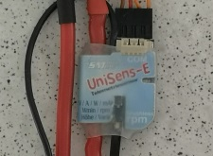

The UniSens E allows live data to be saved via the serial interface (adapter required). The function is comparable to the UniLog 2, without cell voltages.

UT61E, UT71BCDE from UniTrend
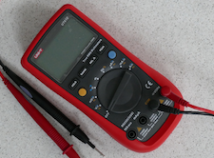
The device dialog can be used to start data gathering with the measurement and unit adjusted at the device. Data can only be captured and the device is giving range and unit. Data can exclusively received, the meter device dictates the time steps between two data point and depends on adjusted unit and range.
For long therm measurements it is possible to extend the time step, skipping internal dictated time step, changing the device XML. But only time step values above 1000.0 msec make a difference (example 60000.0 msec for one measurement/minute). It is showing information about the adjusted measurement type and battery condition.
Switching the measurement unit or range at the multimeter itself will create a new data set.

VC820/840 from Conrad
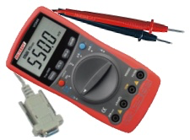
The VC820/840 device dialog might be used to start and stop data collection. Data can exclusively received, the meter device normally dictates the time steps between two data point. For long therm measurements it is possible to extend the time step, skipping internal dictated time step, changing the device XML. But only time step values above 1000.0 msec make a difference (example 60000.0 msec for one measurement/minute). It is showing information about the adjusted measurement type and battery condition.

The start button can be used to initiate data collection. Nevertheless the "start gathering" button can be used instead without opening this dialog.

Switching the measurement unit or range at the multimeter itself will create a new data set.
Pushing the "stop" button will stop gathering data.

Weatronic-Telemetrie

The Weatronic transmitter will record a high number of telemetry data as well as transmitter data in binary form. Just finished the implementation for the telemetry analysis the company closed and the support for this RC control system get obsolete.
The number of measurements as well as the sequence depends on the connected sensors. Therefore there are four configurations available to be used to import the data in different sensor combinations and resulting measurement sets.

Weatronic-Dialog
The Weatronic device dialog can only be used to get an overview regarding the measurements and to configure filters to exclude some measurements to keep the overview.

Usage
There are four configurations to be used for different measurement sets or sensor combinations, to be changed using the device properties editor to configure trigger to have a possible statistic regarding motor runtime, number of climb flight, altitude delta collected by climb flights and so on. This can not be done initially since, as described, the measurement set change using different sensor combinations. Please check out above documentation.
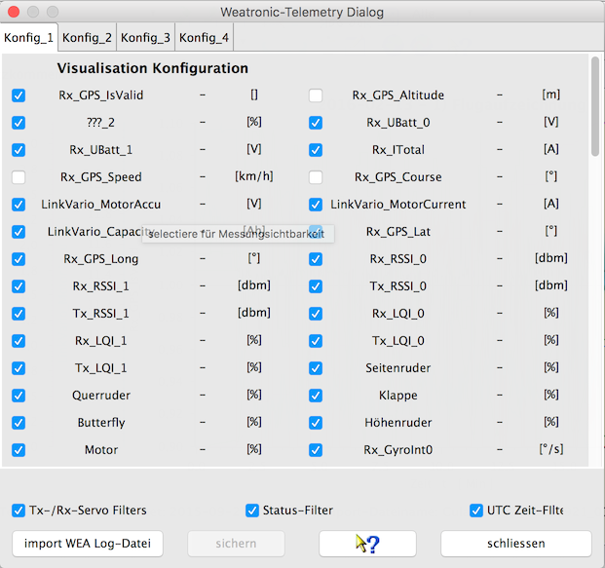

Synchronization of measurements to a single scale
At the operation system depending application configuration directories you will find a folder ..DataExplorer/Mappings. Below this folder there is a XML mapping file to enable synchronization mapping. As example RXSub1_UBatt_1, RXSub2_UBatt_0, RXSub2_UBatt_1 to RXSub1_UBatt_0 get synchronized to RXSub1_UBatt_0:

<entry key="RXSub1_UBatt_1">RXSub1_UBatt_0</entry>
<entry key="RXSub2_UBatt_0">RXSub1_UBatt_0</entry>
<entry key="RXSub2_UBatt_1">RXSub1_UBatt_0</entry>

ZeroAdapter according LogView Specification
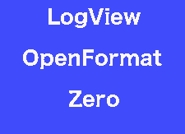

The implementation largely follows the specification created by the LogView project. After selecting this device and importing a file, the configuration is adjusted or completed via the device toolbox (scale synchronization).
Then you change directory which holds the device XML files and change the name according to purpose. Log-files from this device should then always be imported via this device. In this case, the scale synchronization remains and if a graphic template has been generated by this device it will be applied.

